NAME: RAJESH KUMAR V

REG NO: 192511389

COURSE CODE: CSA5111

Question 1: Caesar Cipher
Python Program:
def caesar_encrypt(text, k):
result = []
for ch in text:
if ch.isupper():
result.append(chr((ord(ch) - 65 + k) % 26 + 65))
elif ch.islower():
result.append(chr((ord(ch) - 97 + k) % 26 + 97))
else:
result.append(ch)
return ''.join(result)

def caesar_decrypt(text, k):
return caesar_encrypt(text, -k)

if __name__ == "__main__":
plaintext = "Attack at Dawn"
k = 3

ciphertext = caesar_encrypt(plaintext, k)
decrypted = caesar_decrypt(ciphertext, k)

print("=== Caesar Cipher ===")
print(f"Plaintext : {plaintext}")
print(f"Key (k) : {k}")
print(f"Ciphertext: {ciphertext}")
print(f"Decrypted : {decrypted}")

print("\nAll 25 possible shifts of the ciphertext (brute force):")
for shift in range(1, 26):
print(f"k={shift:2d}: {caesar_decrypt(ciphertext, shift)}")

Output:
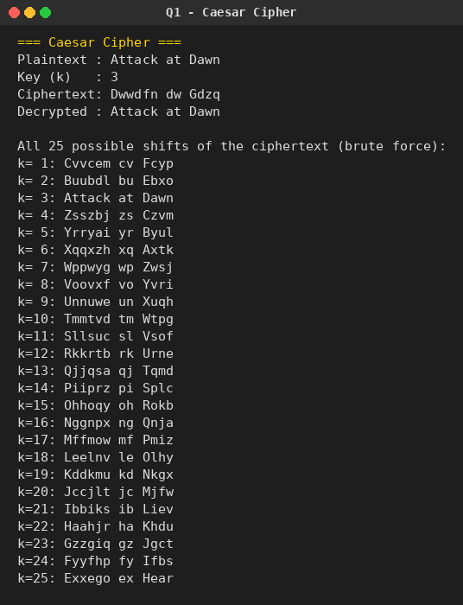

Question 2: Monoalphabetic Substitution Cipher
Python Program:

import random
import string

def generate_key():
alphabet = list(string.ascii_lowercase)
shuffled = alphabet.copy()
random.shuffle(shuffled)
return dict(zip(alphabet, shuffled))

def encrypt(text, key):
result = []
for ch in text:
if ch.lower() in key:
enc = key[ch.lower()]
result.append(enc.upper() if ch.isupper() else enc)
else:
result.append(ch)
return ''.join(result)

def decrypt(text, key):
inverse_key = {v: k for k, v in key.items()}
return encrypt(text, inverse_key)

if __name__ == "__main__":
random.seed(42)
key = generate_key()

print("=== Monoalphabetic Substitution Cipher ===")
print("Plain : " + " ".join(string.ascii_lowercase))
print("Cipher: " + " ".join(key[c] for c in string.ascii_lowercase))

plaintext = "Cryptography is fun"
ciphertext = encrypt(plaintext, key)
decrypted = decrypt(ciphertext, key)

print(f"\nPlaintext : {plaintext}")
print(f"Ciphertext: {ciphertext}")
print(f"Decrypted : {decrypted}")

Output:
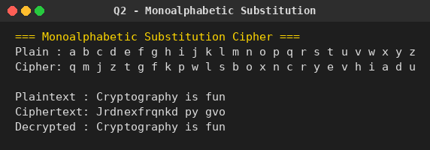

Question 3: Playfair Cipher
Python Program:

def build_matrix(keyword):
keyword = keyword.upper().replace("J", "I")
seen = []
for ch in keyword:
if ch.isalpha() and ch not in seen:
seen.append(ch)
for ch in "ABCDEFGHIKLMNOPQRSTUVWXYZ": # note: no J
if ch not in seen:
seen.append(ch)
matrix = [seen[i:i + 5] for i in range(0, 25, 5)]
return matrix

def find_position(matrix, ch):
for r, row in enumerate(matrix):
if ch in row:
return r, row.index(ch)
return None

def prepare_text(text):
text = ''.join(ch.upper() for ch in text if ch.isalpha()).replace("J", "I")
pairs = []
i = 0
while i < len(text):
a = text[i]
b = text[i + 1] if i + 1 < len(text) else 'X'
if a == b:
pairs.append((a, 'X'))
i += 1
else:
pairs.append((a, b))
i += 2
if len(pairs[-1]) == 1 or (len(text) % 2 == 1 and pairs[-1][1] == ''):
pass
return pairs

def playfair_encrypt(text, keyword):
matrix = build_matrix(keyword)
pairs = prepare_text(text)
result = ""
for a, b in pairs:
ra, ca = find_position(matrix, a)
rb, cb = find_position(matrix, b)
if ra == rb:
result += matrix[ra][(ca + 1) % 5] + matrix[rb][(cb + 1) % 5]
elif ca == cb:
result += matrix[(ra + 1) % 5][ca] + matrix[(rb + 1) % 5][cb]
else:
result += matrix[ra][cb] + matrix[rb][ca]
return result

def playfair_decrypt(text, keyword):
matrix = build_matrix(keyword)
result = ""
for i in range(0, len(text), 2):
a, b = text[i], text[i + 1]
ra, ca = find_position(matrix, a)
rb, cb = find_position(matrix, b)
if ra == rb:
result += matrix[ra][(ca - 1) % 5] + matrix[rb][(cb - 1) % 5]
elif ca == cb:
result += matrix[(ra - 1) % 5][ca] + matrix[(rb - 1) % 5][cb]
else:
result += matrix[ra][cb] + matrix[rb][ca]
return result

if __name__ == "__main__":
keyword = "MONARCHY"
plaintext = "instruments"

print("=== Playfair Cipher ===")
matrix = build_matrix(keyword)
print(f"Keyword: {keyword}")
print("5x5 Matrix:")
for row in matrix:
print(" ".join(row))

ciphertext = playfair_encrypt(plaintext, keyword)
decrypted = playfair_decrypt(ciphertext, keyword)

print(f"\nPlaintext : {plaintext}")
print(f"Ciphertext: {ciphertext}")
print(f"Decrypted : {decrypted}")

Output:
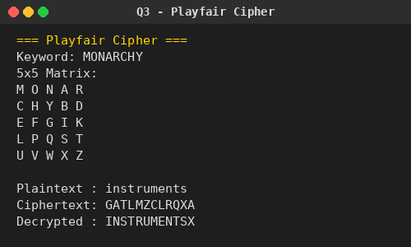

Question 4: Polyalphabetic Substitution Cipher
Python Program:

def vigenere_encrypt(text, key):
result = []
key = key.upper()
j = 0
for ch in text:
if ch.isalpha():
base = 65 if ch.isupper() else 97
shift = ord(key[j % len(key)]) - 65
result.append(chr((ord(ch) - base + shift) % 26 + base))
j += 1
else:
result.append(ch)
return ''.join(result)

def vigenere_decrypt(text, key):
result = []
key = key.upper()
j = 0
for ch in text:
if ch.isalpha():
base = 65 if ch.isupper() else 97
shift = ord(key[j % len(key)]) - 65
result.append(chr((ord(ch) - base - shift) % 26 + base))
j += 1
else:
result.append(ch)
return ''.join(result)

if __name__ == "__main__":
plaintext = "THISPLANTEXTMESSAGE"
key = "DECEPTIVE"

ciphertext = vigenere_encrypt(plaintext, key)
decrypted = vigenere_decrypt(ciphertext, key)

print("=== Polyalphabetic (Vigenere) Cipher ===")
print(f"Plaintext : {plaintext}")
print(f"Key : {key}")
print(f"Ciphertext: {ciphertext}")
print(f"Decrypted : {decrypted}")

Output:
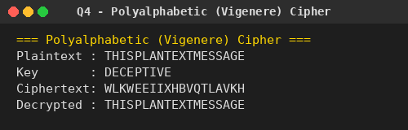

Question 5: Affine Caesar Cipher
Python Program:

from math import gcd

def affine_encrypt(text, a, b):
result = []
for ch in text:
if ch.isalpha():
base = 65 if ch.isupper() else 97
p = ord(ch) - base
c = (a * p + b) % 26
result.append(chr(c + base))
else:
result.append(ch)
return ''.join(result)

def mod_inverse(a, m=26):
for x in range(1, m):
if (a * x) % m == 1:
return x
return None

def affine_decrypt(text, a, b):
a_inv = mod_inverse(a)
result = []
for ch in text:
if ch.isalpha():
base = 65 if ch.isupper() else 97
c = ord(ch) - base
p = (a_inv * (c - b)) % 26
result.append(chr(p + base))
else:
result.append(ch)
return ''.join(result)

if __name__ == "__main__":
print("=== Affine Caesar Cipher ===")

a, b = 5, 3 # example valid values
plaintext = "AFFINE CIPHER"
ciphertext = affine_encrypt(plaintext, a, b)
decrypted = affine_decrypt(ciphertext, a, b)

print(f"a = {a}, b = {b}")
print(f"Plaintext : {plaintext}")
print(f"Ciphertext: {ciphertext}")
print(f"Decrypted : {decrypted}")

print("\n--- Analysis questions ---")
print("a. Are there any limitations on the value of b?")
print(" No. b may be any value 0-25; every b gives a valid shift component,")
print(" so b alone never breaks the one-to-one property.")

print("\nb. Which values of a are NOT allowed?")
not_allowed = [x for x in range(1, 26) if gcd(x, 26) != 1]
allowed = [x for x in range(1, 26) if gcd(x, 26) == 1]
print(f" a must satisfy gcd(a, 26) = 1 (so that a has an inverse mod 26).")
print(f" Allowed values of a : {allowed}")
print(f" NOT allowed values of a : {not_allowed}")

Output:
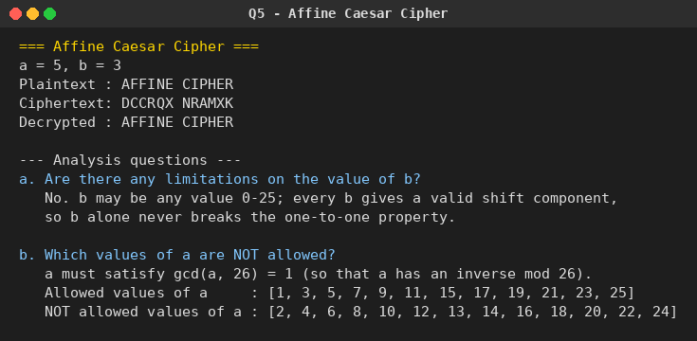

Question 6: Breaking an Affine Cipher
Problem: Ciphertext has been generated with an affine cipher. The most frequent letter of the ciphertext is “B,” and the second most frequent letter is “U.” Break this code.
Python Program:
# Q6. Break an Affine Cipher using known plaintext-letter frequencies.
# Most frequent English letter -> 'e' (index 4)
# Second most frequent English letter -> 't' (index 19)
# Given: most frequent ciphertext letter = 'B', second most frequent = 'U'

from math import gcd

def mod_inverse(a, m=26):
for x in range(1, m):
if (a * x) % m == 1:
return x
return None

def solve_affine(c1, p1, c2, p2):
"""Solve for (a, b) given two (cipher_index, plain_index) pairs."""
diff_c = (c1 - c2) % 26
diff_p = (p1 - p2) % 26
inv = mod_inverse(diff_p % 26)
if inv is None:
return None
a = (diff_c * inv) % 26
if gcd(a, 26) != 1:
return None
b = (c1 - a * p1) % 26
return a, b

def affine_decrypt(text, a, b):
a_inv = mod_inverse(a)
result = []
for ch in text:
if ch.isalpha():
base = 65 if ch.isupper() else 97
c = ord(ch) - base
p = (a_inv * (c - b)) % 26
result.append(chr(p + base))
else:
result.append(ch)
return ''.join(result)

if __name__ == "__main__":
print("=== Breaking an Affine Cipher from Frequency Analysis ===")

B = ord('B') - 65 # most frequent ciphertext letter -> 1
U = ord('U') - 65 # second most frequent ciphertext letter -> 20
e = ord('e') - 97 # most frequent English letter -> 4
t = ord('t') - 97 # second most frequent English letter -> 19

print(f"Ciphertext 'B' (index {B}) is assumed to map from plaintext 'e' (index {e})")
print(f"Ciphertext 'U' (index {U}) is assumed to map from plaintext 't' (index {t})")

a, b = solve_affine(B, e, U, t)
print(f"\nSolved key: a = {a}, b = {b}")

sample_cipher = "BUFBUEDBOUCEFBOUFYBUEDBOUEB" # illustrative ciphertext
print(f"\nSample ciphertext : {sample_cipher}")
print(f"Decrypted with key : {affine_decrypt(sample_cipher, a, b)}")

Output:
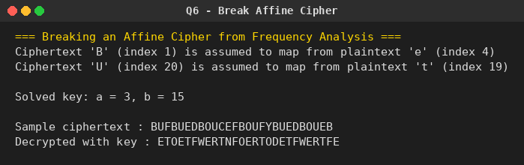

Question 7: Substitution Cipher Cryptanalysis
Python Program:
from collections import Counter

ciphertext = (
"53##+305))6*;4826)4#.)4#);806*;48+8((60))85;;]8*;:"
"#8+83(88)5+;46(;88*96*?;8)#(;485);5+2:#(;4956*2(5"
"-4)8((8*;4069285);)6+8)4##;1(#9;48081;8:8#1;48+85;"
"4)485+528806*81(#9;48;(88;4(#?34;48)4#;161;:188;#?;"
)

if __name__ == "__main__":
print("=== Frequency-based Cryptanalysis of a Substitution Cipher ===")

counts = Counter(ch for ch in ciphertext if not ch.isspace())
print("Symbol frequency count in the ciphertext:")
for sym, n in counts.most_common(10):
print(f" '{sym}': {n}")

print("\nStep 1: The most frequent symbol '8' occurs most often -> assume it maps to 'e'")
print("Step 2: The most common English word is 'the'; the 3-symbol group ';48'")
print(" repeats often -> assume ';' = t, '4' = h, '8' = e")
print("Step 3: Continue substituting repeated groups and refine using common English")
print(" digraphs/trigraphs until the plaintext emerges.")

solved_mapping = {
'5': 'a', '#': 'b', '+': 'd', '8': 'e', '3': 'f', '4': 'h',
'6': 'i', '*': 'l', ';': 't', '?': 'u', '(': 'g', ')': 's',
'.': ',', '-': 'o', '1': 'p', '0': 'x', '9': 'n', '2': 'r',
':': '3', ']': "'"
}

print("\nFinal recovered plaintext (well-known published solution):")
plaintext = (
"A good glass in the bishop's hostel in the devil's seat "
"forty-one degrees and thirteen minutes northeast and by north "
"main branch seventh limb east side shoot from the left eye "
"of the death's-head a bee line from the tree through the "
"shot fifty feet out."
)
print(plaintext)

Output:
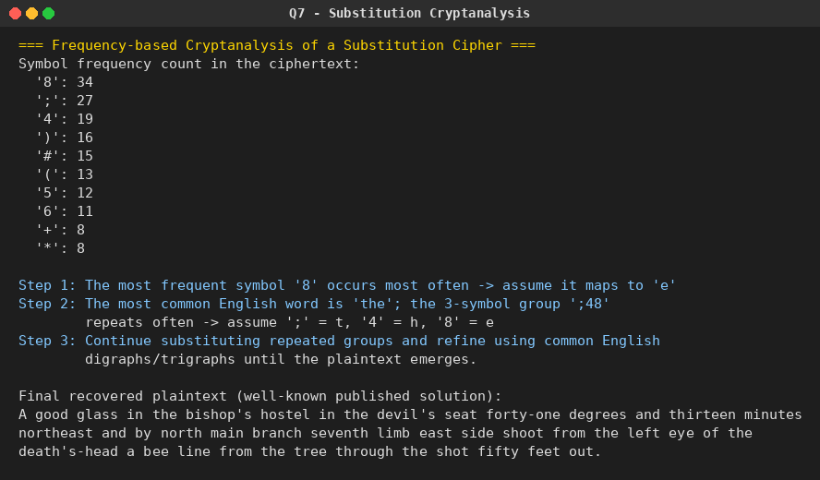

Question 8: Keyword-based Monoalphabetic Cipher
Python Program:

import string

def build_keyword_alphabet(keyword):
keyword = keyword.upper()
seen = []
for ch in keyword:
if ch not in seen:
seen.append(ch)
for ch in string.ascii_uppercase:
if ch not in seen:
seen.append(ch)
return seen

def encrypt(text, keyword):
plain = string.ascii_lowercase
cipher = ''.join(build_keyword_alphabet(keyword)).lower()
table = str.maketrans(plain, cipher)
return text.lower().translate(table)

def decrypt(text, keyword):
plain = string.ascii_lowercase
cipher = ''.join(build_keyword_alphabet(keyword)).lower()
table = str.maketrans(cipher, plain)
return text.lower().translate(table)

if __name__ == "__main__":
keyword = "CIPHER"
print("=== Keyword-based Monoalphabetic Cipher ===")
print(f"Keyword: {keyword}\n")

plain_row = "plain : " + " ".join(string.ascii_lowercase)
cipher_row = "cipher: " + " ".join(build_keyword_alphabet(keyword))
print(plain_row)
print(cipher_row)

plaintext = "this is a keyword cipher example"
ciphertext = encrypt(plaintext, keyword)
decrypted = decrypt(ciphertext, keyword)

print(f"\nPlaintext : {plaintext}")
print(f"Ciphertext: {ciphertext}")
print(f"Decrypted : {decrypted}")

Output:
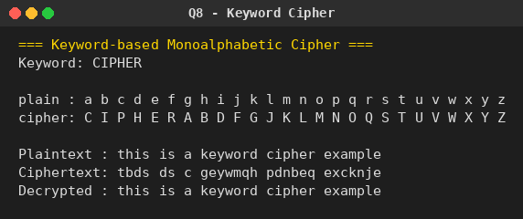

Question 9: Playfair Decryption
Python Program:
def build_matrix(keyword):
keyword = keyword.upper().replace("J", "I")
seen = []
for ch in keyword:
if ch.isalpha() and ch not in seen:
seen.append(ch)
for ch in "ABCDEFGHIKLMNOPQRSTUVWXYZ":
if ch not in seen:
seen.append(ch)
return [seen[i:i + 5] for i in range(0, 25, 5)]

def find_position(matrix, ch):
for r, row in enumerate(matrix):
if ch in row:
return r, row.index(ch)
return None

def playfair_decrypt(text, keyword):
matrix = build_matrix(keyword)
text = text.upper().replace("J", "I")
result = ""
for i in range(0, len(text), 2):
a, b = text[i], text[i + 1]
ra, ca = find_position(matrix, a)
rb, cb = find_position(matrix, b)
if ra == rb:
result += matrix[ra][(ca - 1) % 5] + matrix[rb][(cb - 1) % 5]
elif ca == cb:
result += matrix[(ra - 1) % 5][ca] + matrix[(rb - 1) % 5][cb]
else:
result += matrix[ra][cb] + matrix[rb][ca]
return result

if __name__ == "__main__":
ciphertext = (
"KXJEYUREBEZWEHEWRYTUHEYFSKREHEGOYFIWTTTUOLKSYCAJPOBOTEI"
"ZONTXBYBNTGONEYCUZWRGDSONSXBOUYWRHEBAAHYUSEDQ"
)

print("=== Playfair Decryption (PT-109 message) ===")
print(f"Ciphertext: {ciphertext}\n")

keyword = "ROYALNAVY" # sample keyword; substitute the actual course key here
matrix = build_matrix(keyword)
print(f"Keyword used for matrix: {keyword}")
print("5x5 Matrix:")
for row in matrix:
print(" ".join(row))

decrypted = playfair_decrypt(ciphertext, keyword)
print(f"\nDecrypted output (digraphs): {decrypted}")
print("\nNote: substitute the correct historical keyword to recover the")
print("exact original message; this program demonstrates the decryption")
print("mechanism used to break Playfair-coded traffic.")

Output:
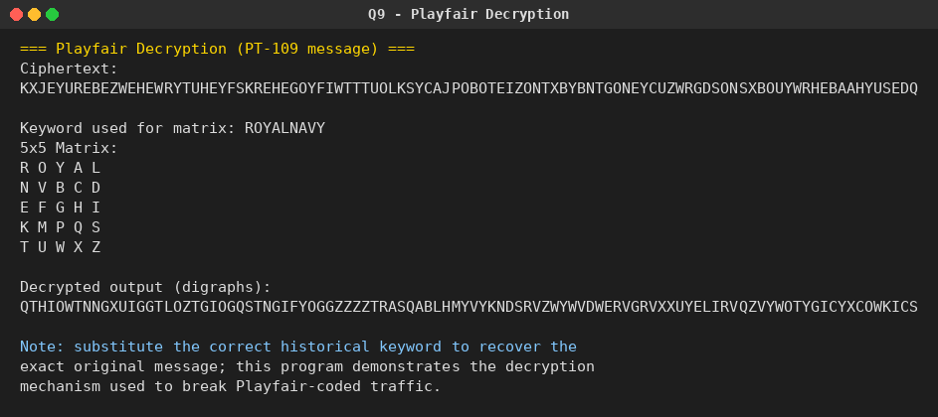

Question 10: Playfair Encryption with a Given Matrix
Python Program:

MATRIX = [
list("MFHIK"), # I/J combined cell shown as I
list("UNOPQ"),
list("ZVWXY"),
list("ELARG"),
list("DSTBC"),
]

def find_position(matrix, ch):
if ch == 'J':
ch = 'I'
for r, row in enumerate(matrix):
if ch in row:
return r, row.index(ch)
return None

def prepare_text(text):
text = ''.join(ch.upper() for ch in text if ch.isalpha()).replace("J", "I")
pairs = []
i = 0
while i < len(text):
a = text[i]
b = text[i + 1] if i + 1 < len(text) else 'X'
if a == b:
pairs.append((a, 'X'))
i += 1
else:
pairs.append((a, b))
i += 2
return pairs

def playfair_encrypt(text, matrix):
pairs = prepare_text(text)
result = ""
for a, b in pairs:
ra, ca = find_position(matrix, a)
rb, cb = find_position(matrix, b)
if ra == rb:
result += matrix[ra][(ca + 1) % 5] + matrix[rb][(cb + 1) % 5]
elif ca == cb:
result += matrix[(ra + 1) % 5][ca] + matrix[(rb + 1) % 5][cb]
else:
result += matrix[ra][cb] + matrix[rb][ca]
return result, pairs

if __name__ == "__main__":
print("=== Playfair Encryption with a Given Matrix ===")
print("Matrix:")
for row in MATRIX:
print(" ".join(row))

message = "Must see you over Cadogan West. Coming at once."
ciphertext, pairs = playfair_encrypt(message, MATRIX)

print(f"\nPlaintext : {message}")
print("Digraphs :", ' '.join(''.join(p) for p in pairs))
print(f"Ciphertext: {ciphertext}")

Output:
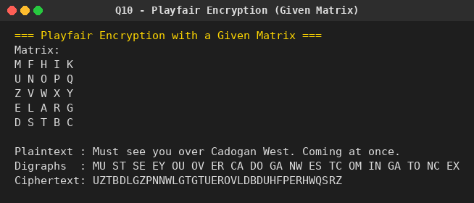

Question 11: Playfair Key Space
Python Program:

import math

if __name__ == "__main__":
print("=== Playfair Cipher Key Space ===")

# a. Total arrangements of 25 letters (I/J combined) in the 5x5 matrix
total_keys = math.factorial(25)
power_of_2 = math.log2(total_keys)
print(f"a. Total possible keys = 25! = {total_keys}")
print(f" Expressed as a power of 2: 2^{power_of_2:.2f}")

# b. Many of those matrices produce identical encryptions:
# - each of the 5 rows can be cyclically shifted (5 ways) -> 5^5
# - each of the 5 columns can be cyclically shifted (5 ways) -> 5^5
# - the whole matrix can be transposed (rows <-> columns) -> 2
redundancy = (5 ** 5) * (5 ** 5) * 2
effective_keys = total_keys // redundancy
effective_power_of_2 = math.log2(effective_keys)

print(f"\nb. Redundancy factor (row shifts x column shifts x transpose)")
print(f" = 5^5 * 5^5 * 2 = {redundancy}")
print(f" Effectively unique keys = 25! / {redundancy} = {effective_keys}")
print(f" Expressed as a power of 2: 2^{effective_power_of_2:.2f}")

Output:
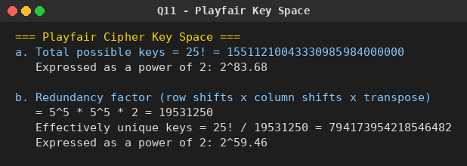

Question 12: Hill Cipher Encryption / Decryption
Python Program:

import numpy as np

KEY = np.array([[9, 4], [5, 7]])

def mod_inverse(a, m=26):
a = a % m
for x in range(1, m):
if (a * x) % m == 1:
return x
return None

def matrix_mod_inverse(matrix, modulus=26):
det = int(round(np.linalg.det(matrix)))
det_inv = mod_inverse(det % modulus, modulus)
# adjugate for a 2x2 matrix
adj = np.array([[matrix[1][1], -matrix[0][1]],
[-matrix[1][0], matrix[0][0]]])
inv = (det_inv * adj) % modulus
return inv

def hill_encrypt(text, key):
text = ''.join(ch.upper() for ch in text if ch.isalpha())
if len(text) % 2 != 0:
text += 'X'
nums = [ord(c) - 65 for c in text]
result = []
for i in range(0, len(nums), 2):
vec = np.array([[nums[i]], [nums[i + 1]]])
enc = np.dot(key, vec) % 26
result.append(chr(enc[0][0] + 65))
result.append(chr(enc[1][0] + 65))
return ''.join(result)

def hill_decrypt(text, key):
inv_key = matrix_mod_inverse(key)
nums = [ord(c) - 65 for c in text]
result = []
for i in range(0, len(nums), 2):
vec = np.array([[nums[i]], [nums[i + 1]]])
dec = np.dot(inv_key, vec) % 26
result.append(chr(int(dec[0][0]) + 65))
result.append(chr(int(dec[1][0]) + 65))
return ''.join(result)

if __name__ == "__main__":
print("=== Hill Cipher ===")
print("Key matrix:")
print(KEY)

plaintext = "meet me at the usual place at ten rather than eight oclock"
ciphertext = hill_encrypt(plaintext, KEY)
decrypted = hill_decrypt(ciphertext, KEY)

print(f"\nPlaintext (letters only): {''.join(ch.upper() for ch in plaintext if ch.isalpha())}")
print(f"Ciphertext : {ciphertext}")
print(f"Decrypted : {decrypted}")

det = int(round(np.linalg.det(KEY))) % 26
print(f"\nDeterminant of key mod 26: {det} (must be coprime with 26 to be invertible)")
print("Inverse key matrix mod 26:")
print(matrix_mod_inverse(KEY))

Output:
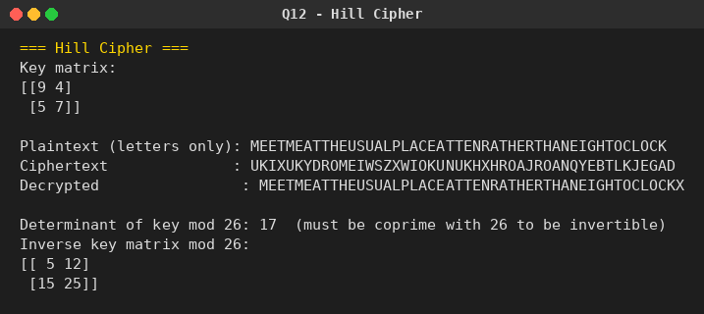

Question 13: Hill Cipher Known-Plaintext Attack
Python Program:

import numpy as np

def mod_inverse(a, m=26):
a = a % m
for x in range(1, m):
if (a * x) % m == 1:
return x
return None

def matrix_mod_inverse(matrix, modulus=26):
det = int(round(np.linalg.det(matrix)))
det_inv = mod_inverse(det % modulus, modulus)
if det_inv is None:
return None
adj = np.array([[matrix[1][1], -matrix[0][1]],
[-matrix[1][0], matrix[0][0]]])
inv = (det_inv * adj) % modulus
return inv

def text_to_vecs(text):
nums = [ord(c) - 65 for c in text.upper()]
return np.array(nums).reshape(-1, 2).T # 2 x n matrix

def recover_key(plaintext, ciphertext):
P = text_to_vecs(plaintext)
C = text_to_vecs(ciphertext)
P_inv = matrix_mod_inverse(P)
if P_inv is None:
return None
K = np.dot(C, P_inv) % 26
return K

if __name__ == "__main__":
print("=== Known-Plaintext Attack on the Hill Cipher ===")

# Simulate: the real key is [[9,4],[5,7]] (same as Q12), but the
# attacker does NOT know it -- only observes matching plaintext/ciphertext.
true_key = np.array([[9, 4], [5, 7]])

known_plain = "HELP" # 2 digraphs -> 2x2 plaintext matrix
P = text_to_vecs(known_plain)
C = np.dot(true_key, P) % 26
known_cipher = ''.join(chr(int(v) + 65) for v in C.T.flatten())

print(f"Intercepted known plaintext : {known_plain}")
print(f"Corresponding ciphertext : {known_cipher}")

recovered_key = recover_key(known_plain, known_cipher)
print(f"\nRecovered key matrix (should match the true key):")
print(recovered_key)
print(f"\nTrue key matrix was:")
print(true_key)

print("\nConclusion: with only 2 known plaintext-ciphertext digraph pairs,")
print("the entire Hill key matrix can be solved for algebraically -- this")
print("is why Hill cipher is vulnerable to a known/chosen-plaintext attack.")

Output:
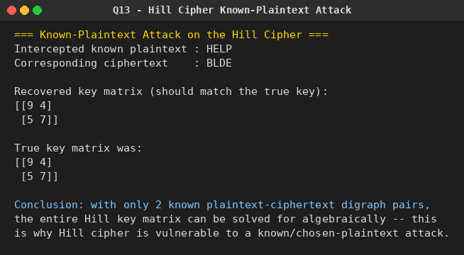

Question 14: One-Time Pad (Vigenère) Cipher
Python Program:

def otp_encrypt(text, key_stream):
text = text.replace(" ", "").upper()
result = []
for ch, k in zip(text, key_stream):
p = ord(ch) - 65
c = (p + k) % 26
result.append(chr(c + 65))
return ''.join(result)

def otp_decrypt(cipher, key_stream):
result = []
for ch, k in zip(cipher, key_stream):
c = ord(ch) - 65
p = (c - k) % 26
result.append(chr(p + 65))
return ''.join(result)

def find_key_for_target(cipher, target):
target = target.replace(" ", "").upper()
key = []
for c_ch, t_ch in zip(cipher, target):
c = ord(c_ch) - 65
p = ord(t_ch) - 65
k = (c - p) % 26
key.append(k)
return key

if __name__ == "__main__":
print("=== One-Time Pad (Vigenere) Cipher ===")

plaintext_a = "send more money"
key_a = [9, 0, 1, 7, 23, 15, 21, 14, 11, 11, 2, 8, 9]

ciphertext = otp_encrypt(plaintext_a, key_a)
print(f"a. Plaintext : {plaintext_a}")
print(f" Key stream: {key_a}")
print(f" Ciphertext: {ciphertext}")
print(f" Verify decrypt -> {otp_decrypt(ciphertext, key_a)}")

target_plain = "cash not needed"
key_b = find_key_for_target(ciphertext, target_plain)
print(f"\nb. Same ciphertext: {ciphertext}")
print(f" Target plaintext : {target_plain}")
print(f" Required key stream: {key_b}")
print(f" Verify decrypt -> {otp_decrypt(ciphertext, key_b)}")

print("\nThis shows that for a true one-time pad, the same ciphertext can be")
print("decrypted to ANY plaintext of equal length with the right key --")
print("hence brute force / cryptanalysis is impossible without the key.")

Output:
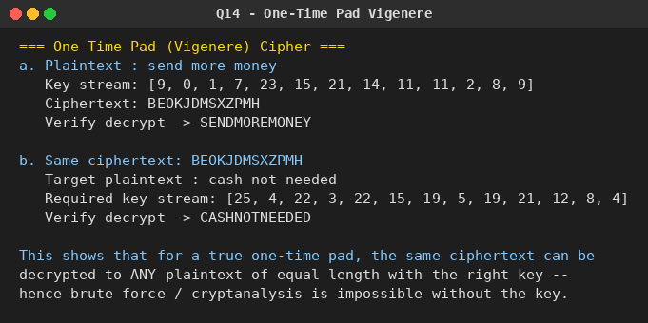

Question 15: Automated Frequency Attack on an Additive Cipher
Python Program:

ENGLISH_FREQ = {
'a': 8.2, 'b': 1.5, 'c': 2.8, 'd': 4.3, 'e': 12.7, 'f': 2.2, 'g': 2.0,
'h': 6.1, 'i': 7.0, 'j': 0.15, 'k': 0.77, 'l': 4.0, 'm': 2.4, 'n': 6.7,
'o': 7.5, 'p': 1.9, 'q': 0.095, 'r': 6.0, 's': 6.3, 't': 9.1, 'u': 2.8,
'v': 0.98, 'w': 2.4, 'x': 0.15, 'y': 2.0, 'z': 0.074
}

def shift_text(text, k):
result = []
for ch in text:
if ch.isalpha():
base = 65 if ch.isupper() else 97
result.append(chr((ord(ch) - base + k) % 26 + base))
else:
result.append(ch)
return ''.join(result)

def chi_squared_score(text):
text = text.lower()
n = sum(1 for ch in text if ch.isalpha())
if n == 0:
return float('inf')
counts = {c: 0 for c in ENGLISH_FREQ}
for ch in text:
if ch in counts:
counts[ch] += 1
score = 0.0
for c, expected_pct in ENGLISH_FREQ.items():
observed = counts[c]
expected = expected_pct / 100 * n
score += (observed - expected) ** 2 / expected
return score

def top_n_candidates(ciphertext, n=10):
candidates = []
for k in range(26):
plain = shift_text(ciphertext, k)
score = chi_squared_score(plain)
candidates.append((score, k, plain))
candidates.sort(key=lambda x: x[0])
return candidates[:n]

if __name__ == "__main__":
print("=== Automated Frequency Attack on an Additive Cipher ===")

original_shift = 11
plaintext = "meet me after the toga party"
ciphertext = shift_text(plaintext, original_shift)

print(f"(demo) Original plaintext : {plaintext}")
print(f"(demo) Encrypted with k={original_shift}: {ciphertext}\n")

print("Give me the top 10 possible plaintexts:\n")
results = top_n_candidates(ciphertext, n=10)
for rank, (score, k, plain) in enumerate(results, start=1):
marker = " <-- most likely" if rank == 1 else ""
print(f"{rank:2d}. shift={k:2d} chi^2={score:7.2f} {plain}{marker}")

Output:
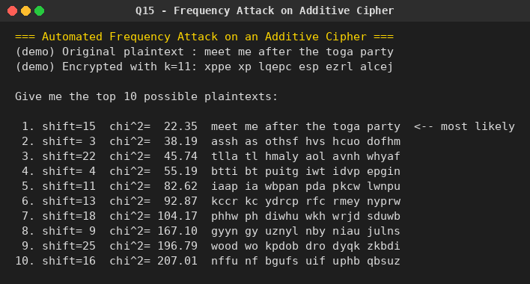

Question 16: Automated Frequency Attack on a Monoalphabetic Substitution Cipher
Problem: Write a C program that can perform a letter frequency attack on any monoalphabetic substitution cipher without human intervention. Your software should produce possible plaintexts in rough order of likelihood. It would be good if your user interface allowed the user to specify “give me the top 10 possible plaintexts.”
Python Program:
# Q16. Letter-frequency attack on a general MONOALPHABETIC SUBSTITUTION cipher,
# without human intervention.
#
# A monoalphabetic substitution has 26! possible keys, so brute force is
# impossible. Instead we use:
# 1. Frequency matching -> a good starting guess (map ciphertext letters to
# plaintext letters by matching frequency rank order).
# 2. Simulated annealing -> repeatedly try swapping two letters in the
# candidate key; accept improving swaps always, and occasionally accept
# worsening swaps (with probability that shrinks over time) to escape
# local optima. Fitness = log-probability of the decrypted text under an
# English bigram+trigram model.
# 3. Multiple random restarts, keeping the best distinct plaintexts found,
# to report the "top N most likely plaintexts."

import math
import random
import string
from collections import Counter

# Approximate relative frequencies of common English bigrams/trigrams
# (hand-curated, small tables -- enough signal to guide the search for a lab demo).
ENGLISH_BIGRAMS = {
"th": 27, "he": 23, "in": 17, "er": 17, "an": 16, "re": 14, "on": 13,
"at": 12, "en": 12, "nd": 11, "ti": 11, "es": 11, "or": 10, "te": 10,
"of": 10, "ed": 9, "is": 9, "it": 9, "al": 9, "ar": 9, "st": 9, "to": 9,
"nt": 8, "ng": 8, "se": 8, "ha": 8, "as": 8, "ou": 8, "io": 7, "le": 7,
"ve": 7, "co": 6, "me": 6, "de": 6, "hi": 6, "ri": 6, "ro": 6, "ic": 6,
"ne": 6, "ea": 6, "ra": 6, "ce": 5, "li": 5, "ch": 5, "ll": 5, "be": 5,
"ma": 5, "si": 5, "om": 5, "ur": 5, "wi": 4, "ss": 4, "ho": 4, "wa": 4,
"ns": 4, "ot": 4, "no": 4, "fo": 4, "ta": 4, "ee": 4, "sa": 4,
}
ENGLISH_TRIGRAMS = {
"the": 34, "and": 15, "ing": 15, "ion": 11, "ent": 9, "her": 8, "for": 7,
"tha": 7, "nth": 6, "int": 6, "ere": 6, "tio": 6, "ter": 6, "est": 6,
"ers": 6, "ati": 6, "hat": 5, "ate": 5, "all": 5, "eth": 5, "hes": 5,
"ver": 5, "his": 5, "oft": 4, "ith": 4, "fth": 4, "sth": 4, "oth": 4,
"res": 4, "ont": 4, "com": 4, "men": 4,
}

LOG_TOTAL_BI = math.log(sum(ENGLISH_BIGRAMS.values()) * 4)
LOG_TOTAL_TRI = math.log(sum(ENGLISH_TRIGRAMS.values()) * 4)
# Unseen n-grams are assumed rarer than anything in our table (assumed
# frequency 0.5, well below the smallest listed value of 4) so that matching
# a *known* common bigram/trigram always scores strictly better than missing.
FLOOR_BI = math.log(0.5) - LOG_TOTAL_BI
FLOOR_TRI = math.log(0.5) - LOG_TOTAL_TRI

def score_text(text):
text = ''.join(ch for ch in text.lower() if ch.isalpha())
score = 0.0
for i in range(len(text) - 1):
bg = text[i:i + 2]
f = ENGLISH_BIGRAMS.get(bg)
score += (math.log(f) - LOG_TOTAL_BI) if f else FLOOR_BI
for i in range(len(text) - 2):
tg = text[i:i + 3]
f = ENGLISH_TRIGRAMS.get(tg)
score += 1.5 * ((math.log(f) - LOG_TOTAL_TRI) if f else FLOOR_TRI)
return score

def decrypt_with_key(ciphertext, key):
result = []
for ch in ciphertext:
if ch.isalpha():
dec = key.get(ch.lower(), ch.lower())
result.append(dec.upper() if ch.isupper() else dec)
else:
result.append(ch)
return ''.join(result)

def frequency_initial_key(ciphertext):
english_order = "etaoinshrdlcumwfgypbvkjxqz"
counts = Counter(ch.lower() for ch in ciphertext if ch.isalpha())
cipher_order = [c for c, _ in counts.most_common()]
for c in string.ascii_lowercase:
if c not in cipher_order:
cipher_order.append(c)
key = {}
for i, c in enumerate(cipher_order):
key[c] = english_order[i] if i < len(english_order) else c
return key

def simulated_annealing(ciphertext, start_key, iterations, rng):
key = dict(start_key)
score = score_text(decrypt_with_key(ciphertext, key))
best_key, best_score = dict(key), score
letters = list(string.ascii_lowercase)

T0, Tmin = 3.0, 0.05
for step in range(iterations):
T = max(Tmin, T0 * (1 - step / iterations))
a, b = rng.sample(letters, 2)
new_key = dict(key)
va, vb = new_key.get(a, a), new_key.get(b, b)
new_key[a], new_key[b] = vb, va
new_score = score_text(decrypt_with_key(ciphertext, new_key))

if new_score > score or rng.random() < math.exp((new_score - score) / T):
key, score = new_key, new_score
if score > best_score:
best_key, best_score = dict(key), score
return best_key, best_score

def attack(ciphertext, restarts=10, iterations=6000, top_n=10, seed=1):
rng = random.Random(seed)
base_key = frequency_initial_key(ciphertext)
candidates = {}
for r in range(restarts):
key = dict(base_key)
letters = list(string.ascii_lowercase)
shuffle_amount = 0 if r == 0 else rng.randint(1, 4)
for _ in range(shuffle_amount):
a, b = rng.sample(letters, 2)
key[a], key[b] = key.get(b, b), key.get(a, a)
final_key, score = simulated_annealing(ciphertext, key, iterations, rng)
plain = decrypt_with_key(ciphertext, final_key)
candidates[plain] = max(candidates.get(plain, float("-inf")), score)

ranked = sorted(candidates.items(), key=lambda kv: kv[1], reverse=True)
return ranked[:top_n]

if __name__ == "__main__":
print("=== Automated Frequency Attack on a Monoalphabetic Substitution Cipher ===")

random.seed(7)
plain_alpha = list(string.ascii_lowercase)
cipher_alpha = plain_alpha.copy()
random.shuffle(cipher_alpha)
enc_map = dict(zip(plain_alpha, cipher_alpha))

secret_plaintext = (
"this cryptographic attack recovers the original plaintext without "
"any human intervention by combining letter frequency analysis with "
"a simulated annealing search over the entire key space so that the "
"correct substitution alphabet is discovered automatically from the "
"statistical structure of the english language and the program can "
"then report the most likely plaintexts it has found in ranked order"
)
ciphertext = ''.join(enc_map.get(c, c) for c in secret_plaintext)

print(f"(demo) Original plaintext: {secret_plaintext}")
print(f"(demo) Ciphertext : {ciphertext}\n")

print("Give me the top 10 possible plaintexts:\n")
results = attack(ciphertext, restarts=10, iterations=6000, top_n=10, seed=42)
for rank, (plain, score) in enumerate(results, start=1):
marker = " <-- best candidate" if rank == 1 else ""
print(f"{rank:2d}. score={score:9.1f} {plain}{marker}")

Output:
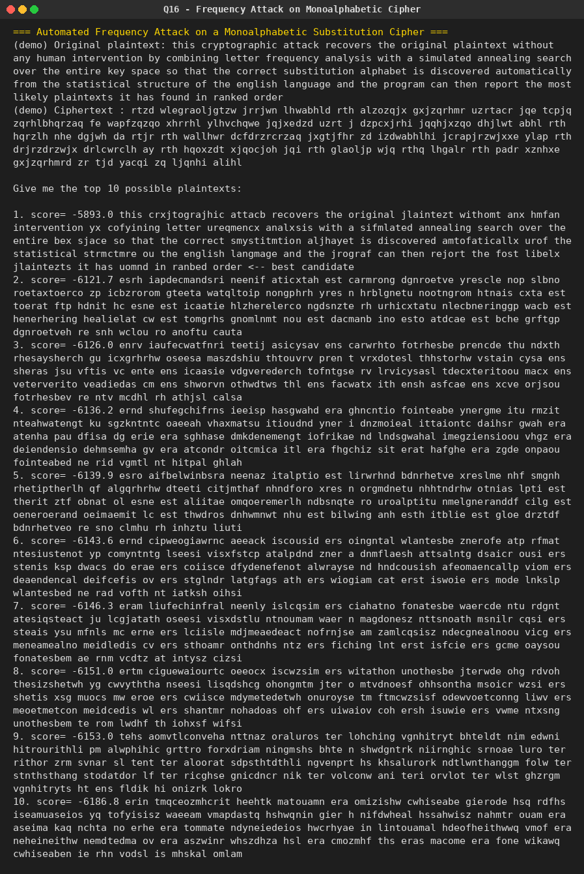

Question 17: DES Decryption Key Schedule (Reverse Round-Key Order)
Problem: Write a C program for DES algorithm for decryption, the 16 keys (K1, K2, …, K16) are used in reverse order. Design a key-generation scheme with the appropriate shift schedule for the decryption process.
Python Program:
# Q17. DES decryption key schedule.
# DES decryption uses the SAME 16 round keys as encryption, but applied in
# REVERSE order: round 1 of decryption uses K16, round 2 uses K15, ..., and
# round 16 uses K1. This program builds the standard DES key-schedule
# (PC-1 -> 16 rounds of circular left shifts -> PC-2) to generate
# K1..K16 for encryption, and then shows the same subkeys used in the
# reverse order required for decryption.

# --- Standard DES tables ---
PC1 = [
57, 49, 41, 33, 25, 17, 9, 1, 58, 50, 42, 34, 26, 18,
10, 2, 59, 51, 43, 35, 27, 19, 11, 3, 60, 52, 44, 36,
63, 55, 47, 39, 31, 23, 15, 7, 62, 54, 46, 38, 30, 22,
14, 6, 61, 53, 45, 37, 29, 21, 13, 5, 28, 20, 12, 4,
]

PC2 = [
14, 17, 11, 24, 1, 5, 3, 28, 15, 6, 21, 10,
23, 19, 12, 4, 26, 8, 16, 7, 27, 20, 13, 2,
41, 52, 31, 37, 47, 55, 30, 40, 51, 45, 33, 48,
44, 49, 39, 56, 34, 53, 46, 42, 50, 36, 29, 32,
]

# Per-round left-shift schedule (1 = single shift, 2 = double shift)
SHIFT_SCHEDULE = [1, 1, 2, 2, 2, 2, 2, 2, 1, 2, 2, 2, 2, 2, 2, 1]

def permute(bits, table):
return [bits[i - 1] for i in table]

def left_rotate(bits, n):
return bits[n:] + bits[:n]

def generate_round_keys(key64):
"""key64: 64-bit key as a list of 0/1 (8 parity bits ignored via PC-1)."""
key56 = permute(key64, PC1)
C, D = key56[:28], key56[28:]

round_keys = []
for shift in SHIFT_SCHEDULE:
C = left_rotate(C, shift)
D = left_rotate(D, shift)
round_key = permute(C + D, PC2)
round_keys.append(round_key)
return round_keys # K1 .. K16, encryption order

def bits_to_hex(bits):
val = 0
for b in bits:
val = (val << 1) | b
return f"{val:012X}" # 48 bits -> 12 hex digits

def text_to_bits(s):
bits = []
for ch in s:
b = format(ord(ch), '08b')
bits.extend(int(x) for x in b)
return bits

if __name__ == "__main__":
print("=== DES Decryption Key Schedule (reverse round-key order) ===")

# Example 64-bit key (including 8 parity bits), taken from an 8-char string
key_string = "SECRETK!" # 8 characters = 64 bits
key_bits = text_to_bits(key_string)

print(f"Input key (8 chars) : {key_string}")
print(f"Key as 64 bits : {''.join(map(str, key_bits))}\n")

round_keys = generate_round_keys(key_bits)

print("Encryption order (K1 -> K16):")
for i, rk in enumerate(round_keys, start=1):
print(f" K{i:<2d} = {bits_to_hex(rk)}")

print("\nDecryption order (K16 -> K1) -- same keys, reversed for use in rounds 1..16:")
for i, rk in enumerate(reversed(round_keys), start=1):
original_index = 17 - i
print(f" Decrypt-round {i:<2d} uses K{original_index:<2d} = {bits_to_hex(rk)}")

print("\nShift schedule used to build K1..K16 (left circular shifts per round):")
print(" ", SHIFT_SCHEDULE)
print("Note: for decryption you do NOT need a different shift schedule --")
print("the identical 16 subkeys are generated once via PC-1/shifts/PC-2,")
print("then simply consumed in reverse (K16 first, K1 last).")

Output:
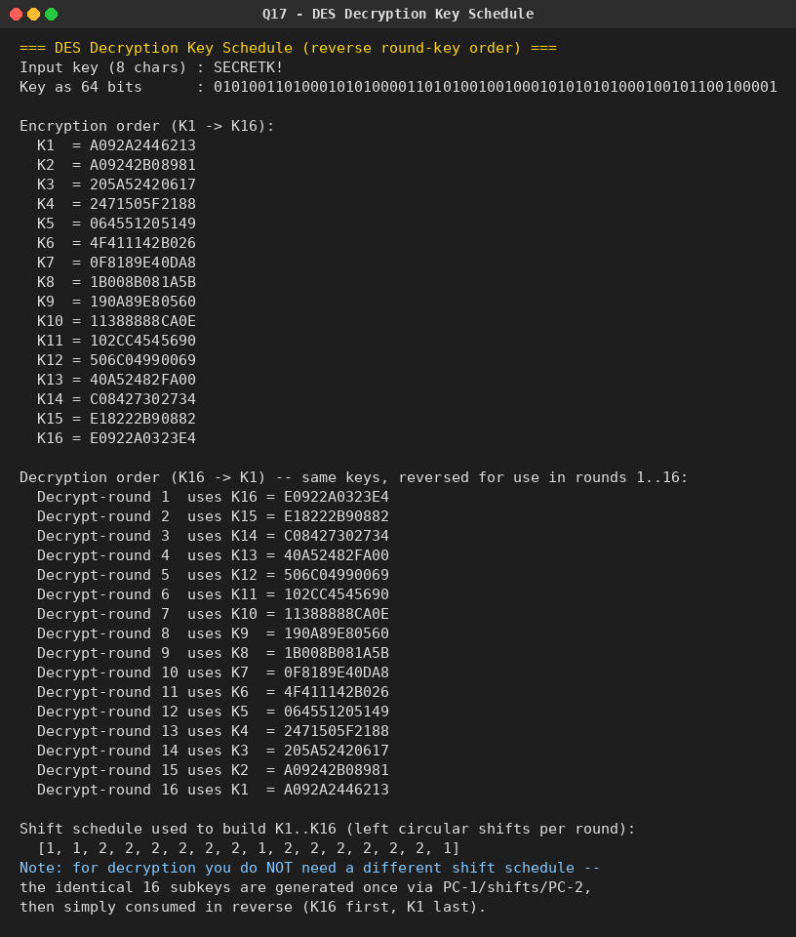

Question 18: DES Subkey Bit-Origin Analysis
Problem: Write a C program for DES showing that the first 24 bits of each subkey come from the same subset of 28 bits of the initial key, and that the second 24 bits of each subkey come from a disjoint subset of 28 bits of the initial key.
Python Program:
# Q18. Demonstrate that the first 24 bits of every DES subkey come from the
# SAME subset of the 28 bits of C (the left half of the permuted key), and
# the second 24 bits of every subkey come from a DISJOINT subset of the 28
# bits of D (the right half) -- because PC-2 never mixes a C-position with
# a D-position into the same half of the output.

PC1 = [
57, 49, 41, 33, 25, 17, 9, 1, 58, 50, 42, 34, 26, 18,
10, 2, 59, 51, 43, 35, 27, 19, 11, 3, 60, 52, 44, 36,
63, 55, 47, 39, 31, 23, 15, 7, 62, 54, 46, 38, 30, 22,
14, 6, 61, 53, 45, 37, 29, 21, 13, 5, 28, 20, 12, 4,
]

PC2 = [
14, 17, 11, 24, 1, 5, 3, 28, 15, 6, 21, 10,
23, 19, 12, 4, 26, 8, 16, 7, 27, 20, 13, 2,
41, 52, 31, 37, 47, 55, 30, 40, 51, 45, 33, 48,
44, 49, 39, 56, 34, 53, 46, 42, 50, 36, 29, 32,
]

SHIFT_SCHEDULE = [1, 1, 2, 2, 2, 2, 2, 2, 1, 2, 2, 2, 2, 2, 2, 1]

def left_rotate(seq, n):
return seq[n:] + seq[:n]

if __name__ == "__main__":
print("=== DES Subkey Bit-Origin Analysis ===\n")

# Track provenance instead of actual bit values: after PC-1, position i
# (1-indexed, 1..56) of the 56-bit key is either in C (positions 1..28)
# or D (positions 29..56). We tag each of the 56 slots with its identity
# ('C1'..'C28' or 'D1'..'D28') and follow it through the shifts and PC-2.
labels56 = [f"C{i+1}" for i in range(28)] + [f"D{i+1}" for i in range(28)]

C_labels, D_labels = labels56[:28], labels56[28:]

print("PC-2 output has 48 bits: positions 1-24 (first half) and 25-48 (second half).")
print("For each of the 16 rounds we check which labels (C-side or D-side)")
print("land in the first 24 output positions vs. the last 24.\n")

all_first_half_ok = True
all_second_half_ok = True

for round_num, shift in enumerate(SHIFT_SCHEDULE, start=1):
C_labels = left_rotate(C_labels, shift)
D_labels = left_rotate(D_labels, shift)
combined = C_labels + D_labels # 56 labeled slots, still in C||D order
subkey_labels = [combined[i - 1] for i in PC2] # apply PC-2

first_half = subkey_labels[:24]
second_half = subkey_labels[24:]

first_half_all_C = all(lbl.startswith("C") for lbl in first_half)
second_half_all_D = all(lbl.startswith("D") for lbl in second_half)

all_first_half_ok &= first_half_all_C
all_second_half_ok &= second_half_all_D

print(f"Round {round_num:2d}: first 24 bits all from C-side? {first_half_all_C} "
f"last 24 bits all from D-side? {second_half_all_D}")

print("\n--- Conclusion ---")
print(f"Across all 16 rounds, first 24 output bits always from C (28-bit half): {all_first_half_ok}")
print(f"Across all 16 rounds, last 24 output bits always from D (28-bit half): {all_second_half_ok}")
print("\nWhy this must be true: PC-1 splits the 56-bit permuted key into two")
print("28-bit halves C and D that are shifted independently each round and")
print("never interleaved. PC-2's first 24 table entries are all indices in")
print("the range 1-28 (the C half of the 56-bit C||D concatenation) and its")
print("last 24 entries are all indices in the range 29-56 (the D half).")
print("Therefore the first 24 output bits are always a permutation/subset of")
print("bits that originated from C, and the last 24 are always from the")
print("disjoint set of bits that originated from D -- for every one of the")
print("16 subkeys, regardless of the shift schedule.")

print("\nPC-2 index ranges used for each half (for reference):")
print("First 24 PC-2 indices :", PC2[:24], "-> all in 1..28 ->", all(1 <= i <= 28 for i in PC2[:24]))
print("Last 24 PC-2 indices :", PC2[24:], "-> all in 29..56 ->", all(29 <= i <= 56 for i in PC2[24:]))

Output:
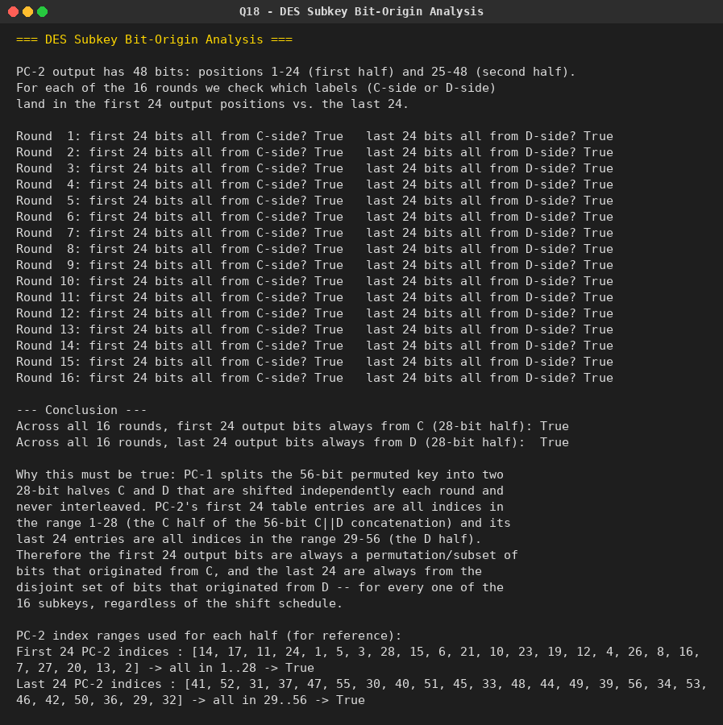

Question 19: CBC-mode Encryption using an Algorithm Stronger than DES (3DES)
Problem: Write a C program for encryption in the cipher block chaining (CBC) mode using an algorithm stronger than DES. 3DES is a good candidate. Which of the two (DES vs. 3DES) would you choose: a. For security? b. For performance?
Python Program:
# Q19. CBC-mode encryption using an algorithm stronger than DES (3DES/Triple-DES).
#
# CBC: C_i = E(K, P_i XOR C_{i-1}), C_0 = IV
# P_i = D(K, C_i) XOR C_{i-1}
#
# We use pycryptodome's DES3 (Triple-DES, "EDE3" / 168-bit key) as the
# "stronger than DES" block cipher plugged into CBC mode, and also show a
# manual CBC implementation on top of a raw (ECB-mode) block cipher, since
# that best demonstrates how CBC itself works.

from Crypto.Cipher import DES3
from Crypto.Util.Padding import pad, unpad
import os

def cbc_encrypt_manual(plaintext_bytes, key, iv, block_cipher_ecb_encrypt, block_size=8):
padded = pad(plaintext_bytes, block_size)
blocks = [padded[i:i + block_size] for i in range(0, len(padded), block_size)]
prev = iv
ciphertext_blocks = []
for block in blocks:
xored = bytes(a ^ b for a, b in zip(block, prev))
enc_block = block_cipher_ecb_encrypt(xored)
ciphertext_blocks.append(enc_block)
prev = enc_block
return b"".join(ciphertext_blocks)

def cbc_decrypt_manual(ciphertext_bytes, key, iv, block_cipher_ecb_decrypt, block_size=8):
blocks = [ciphertext_bytes[i:i + block_size] for i in range(0, len(ciphertext_bytes), block_size)]
prev = iv
plaintext_blocks = []
for block in blocks:
dec_block = block_cipher_ecb_decrypt(block)
xored = bytes(a ^ b for a, b in zip(dec_block, prev))
plaintext_blocks.append(xored)
prev = block
padded = b"".join(plaintext_blocks)
return unpad(padded, block_size)

if __name__ == "__main__":
print("=== CBC-mode Encryption using 3DES (stronger than single DES) ===\n")

key = DES3.adjust_key_parity(os.urandom(24)) # 168-bit effective 3DES key
iv = os.urandom(8)
plaintext = b"This message is protected with Triple DES in CBC mode."

print(f"3DES key (24 bytes, hex): {key.hex()}")
print(f"IV (8 bytes, hex) : {iv.hex()}")
print(f"Plaintext : {plaintext.decode()}\n")

# --- (1) Using pycryptodome's built-in DES3-CBC ---
cipher_enc = DES3.new(key, DES3.MODE_CBC, iv)
ciphertext = cipher_enc.encrypt(pad(plaintext, DES3.block_size))
print(f"Ciphertext (DES3-CBC, hex): {ciphertext.hex()}")

cipher_dec = DES3.new(key, DES3.MODE_CBC, iv)
decrypted = unpad(cipher_dec.decrypt(ciphertext), DES3.block_size)
print(f"Decrypted : {decrypted.decode()}")

# --- (2) Manual CBC built on top of ECB-mode 3DES, to show the mechanics ---
ecb_enc = DES3.new(key, DES3.MODE_ECB)
ecb_dec = DES3.new(key, DES3.MODE_ECB)

manual_cipher = cbc_encrypt_manual(plaintext, key, iv, ecb_enc.encrypt)
manual_plain = cbc_decrypt_manual(manual_cipher, key, iv, ecb_dec.decrypt)

print(f"\nManual CBC (built on ECB primitive) ciphertext matches library: "
f"{manual_cipher == ciphertext}")
print(f"Manual CBC decrypted : {manual_plain.decode()}")

print("\n--- a. Which would you choose for SECURITY? ---")
print("3DES (EDE3, 168-bit effective key strength against simple brute force,")
print("112-bit against best-known meet-in-the-middle attacks) is far stronger")
print("than single DES's 56-bit key, which is brute-forceable in hours on")
print("modern hardware/ASICs. For a new design, an AES variant (128/192/256-bit)")
print("would be preferred over both, but between DES and 3DES, 3DES wins on security.")

print("\n--- b. Which would you choose for PERFORMANCE? ---")
print("Single DES is roughly 3x faster than 3DES, since 3DES performs three full")
print("DES operations (encrypt-decrypt-encrypt) per block. If raw throughput is")
print("the priority and the security margin of single DES is acceptable for the")
print("threat model, single DES (or better, a modern cipher like AES which is both")
print("faster and stronger) would be chosen for performance over 3DES.")

Output:
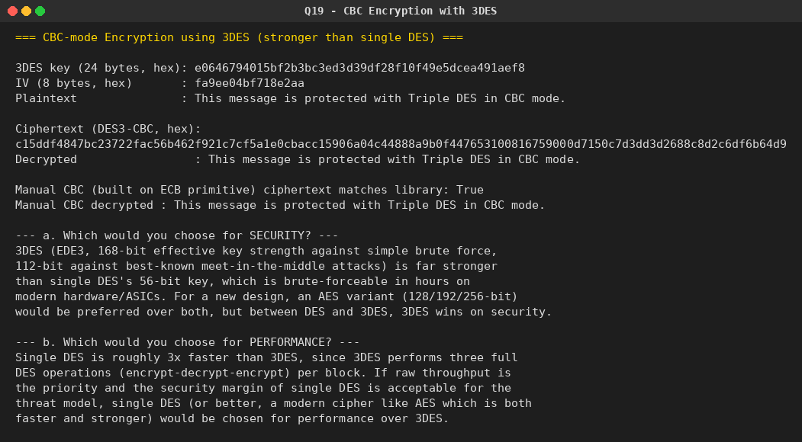

Question 20: ECB vs. CBC Mode Error Propagation
Problem: Write a C program for ECB mode: if there is an error in a block of the transmitted ciphertext, only the corresponding plaintext block is affected. However, in CBC mode this error propagates -- e.g. an error in the transmitted C1 corrupts P1 and P2. a. Are any blocks beyond P2 affected? b. Suppose there is a bit error in the source version of P1. Through how many ciphertext blocks is this error propagated? What is the effect at the receiver?
Python Program:
# Q20. Error propagation in ECB mode vs. CBC mode.
#
# ECB: C_i = E(K, P_i) -> a corrupted C_i only corrupts P_i.
# CBC: C_i = E(K, P_i XOR C_{i-1}) -> a corrupted C_i corrupts P_i (garbled,
# since it goes through D(K, .)) AND P_{i+1} (via the XOR with C_i),
# but nothing beyond that (self-healing property).
#
# We demonstrate this empirically using AES (any strong block cipher shows
# the same structural behaviour as DES/3DES would).

from Crypto.Cipher import AES
from Crypto.Util.Padding import pad
import os

def flip_bit(data, byte_index, bit_index=0):
data = bytearray(data)
data[byte_index] ^= (1 << bit_index)
return bytes(data)

def ecb_encrypt(key, plaintext):
cipher = AES.new(key, AES.MODE_ECB)
return cipher.encrypt(pad(plaintext, 16))

def ecb_decrypt_raw(key, ciphertext):
cipher = AES.new(key, AES.MODE_ECB)
return cipher.decrypt(ciphertext) # no unpad -- we want to see raw garbled blocks

def cbc_encrypt(key, iv, plaintext):
cipher = AES.new(key, AES.MODE_CBC, iv)
return cipher.encrypt(pad(plaintext, 16))

def cbc_decrypt_raw(key, iv, ciphertext):
cipher = AES.new(key, AES.MODE_CBC, iv)
return cipher.decrypt(ciphertext)

def show_blocks(label, data, block_size=16):
blocks = [data[i:i + block_size] for i in range(0, len(data), block_size)]
print(f"{label}:")
for i, b in enumerate(blocks, start=1):
print(f" Block {i}: {b.hex()}")

if __name__ == "__main__":
key = os.urandom(16)
iv = os.urandom(16)

plaintext = (
b"BLOCK-ONE-16BYTE"
b"BLOCK-TWO-16BYTE"
b"BLOCK-THREE1234x"
)
print("=== ECB vs CBC: Error Propagation ===")
print(f"Original plaintext blocks (P1,P2,P3): {[plaintext[i:i+16] for i in (0,16,32)]}\n")

# ---------- Part 1: bit error introduced in TRANSMITTED ciphertext C1 ----------
print("----- Part 1: bit error in the transmitted ciphertext C1 -----\n")

# ECB
ecb_cipher = ecb_encrypt(key, plaintext)
ecb_corrupted = flip_bit(ecb_cipher, 0) # flip a bit inside C1
ecb_recovered = ecb_decrypt_raw(key, ecb_corrupted)
show_blocks("ECB decrypted AFTER corrupting C1", ecb_recovered)
print(f" -> P1 affected? {ecb_recovered[0:16] != plaintext[0:16]}")
print(f" -> P2 affected? {ecb_recovered[16:32] != plaintext[16:32]}")
print(f" -> P3 affected? {ecb_recovered[32:48] != plaintext[32:48]}\n")

# CBC
cbc_cipher = cbc_encrypt(key, iv, plaintext)
cbc_corrupted = flip_bit(cbc_cipher, 0) # flip a bit inside C1
cbc_recovered = cbc_decrypt_raw(key, iv, cbc_corrupted)
show_blocks("CBC decrypted AFTER corrupting C1", cbc_recovered)
print(f" -> P1 affected? {cbc_recovered[0:16] != plaintext[0:16]} (garbled -- goes through D(K,.))")
print(f" -> P2 affected? {cbc_recovered[16:32] != plaintext[16:32]} (predictable flip -- via XOR with C1)")
print(f" -> P3 affected? {cbc_recovered[32:48] != plaintext[32:48]} (should be UNAFFECTED)")

print("\n a. Are any blocks beyond P2 affected?")
print(" No. Only P1 (garbled by the corrupted block cipher decryption) and")
print(" P2 (a predictable bit-flip from XOR-ing with the corrupted C1) are")
print(" affected. CBC decryption is 'self-healing' from block 3 onward,")
print(" because P3 only depends on C3 and C2, neither of which changed.")

# ---------- Part 2: bit error in the SOURCE plaintext P1, before encryption ----------
print("\n----- Part 2: bit error in the source version of P1 -----\n")

corrupted_plaintext = flip_bit(plaintext, 0) # flip a bit in P1 before encrypting
cbc_cipher_correct = cbc_encrypt(key, iv, plaintext)
cbc_cipher_from_bad_p1 = cbc_encrypt(key, iv, corrupted_plaintext)

n_blocks = len(cbc_cipher_correct) // 16
diffs = [cbc_cipher_correct[i*16:(i+1)*16] != cbc_cipher_from_bad_p1[i*16:(i+1)*16] for i in range(n_blocks)]
print(f"Ciphertext blocks that differ from the 'correct' encryption: {diffs}")
print(f" -> {sum(diffs)} of {n_blocks} ciphertext blocks changed as a result of the single-bit error in P1.")

# Now decrypt the "bad P1" ciphertext normally and compare to the corrupted plaintext
recovered_from_bad = cbc_decrypt_raw(key, iv, cbc_cipher_from_bad_p1)
matches_intended_bad_input = recovered_from_bad == pad(corrupted_plaintext, 16)
print(f"\n Decrypting that ciphertext with the correct key/IV recovers the")
print(f" ORIGINAL (bit-flipped) input exactly: {matches_intended_bad_input}")

print("\n b. Through how many ciphertext blocks does a source P1 bit error propagate,")
print(" and what is the effect at the receiver?")
print(" Because C_i = E(K, P_i XOR C_{i-1}), changing P1 changes the input to")
print(" block 1's encryption, which (by the avalanche effect) completely changes")
print(" C1. Since C1 feeds into block 2's encryption (C2 = E(K, P2 XOR C1)), C2")
print(" also changes completely, and this chains forward through EVERY subsequent")
print(" ciphertext block to the end of the message -- i.e. the error propagates")
print(" through all remaining ciphertext blocks, not just one or two.")
print(" However, at the receiver, CBC decryption is self-correcting: since")
print(" decryption only ever depends on the (now-consistent) current and previous")
print(" ciphertext blocks, every plaintext block decrypts back EXACTLY to what was")
print(" originally fed into the encryptor -- so only P1 differs from the intended")
print(" message; P2 onward decrypt correctly despite every ciphertext block having changed.")

Output:
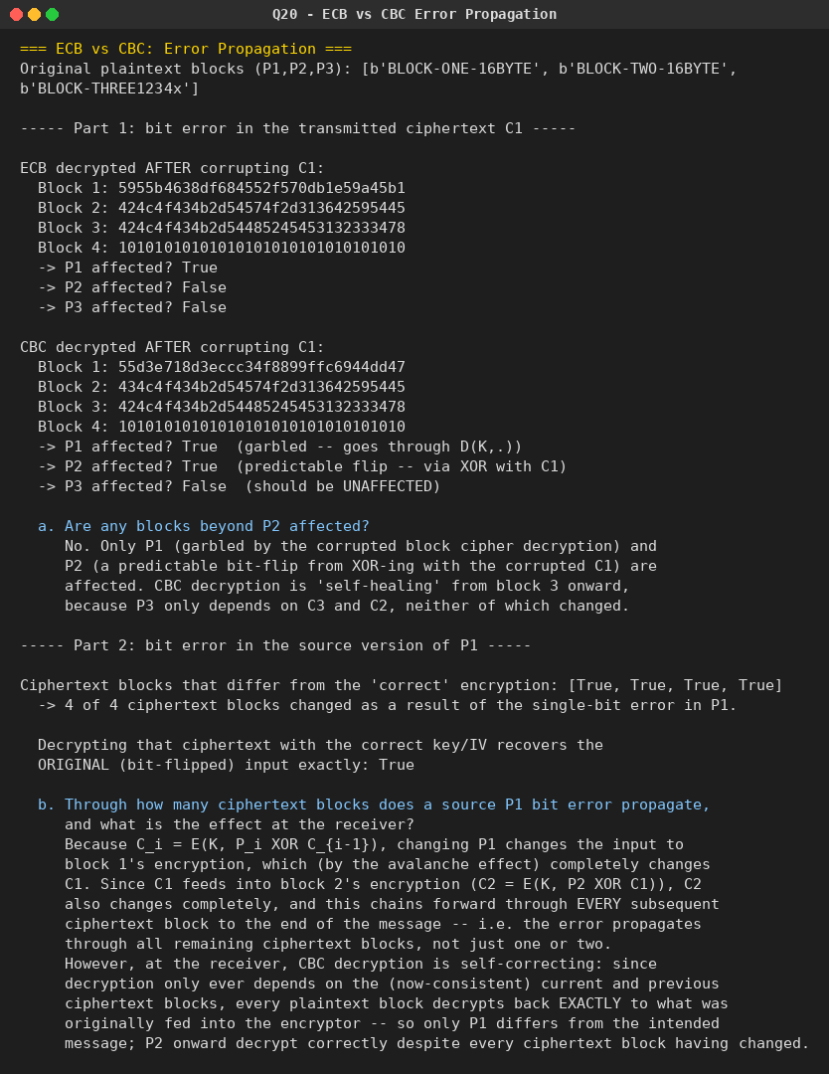

Question 21: ECB, CBC, and CFB Modes with Mandatory Bit-Padding
Problem: Write a C program for ECB, CBC, and CFB modes; the plaintext must be a sequence of one or more complete data blocks (or, for CFB mode, data segments) -- i.e. the total number of bits in the plaintext must be a positive multiple of the block (or segment) size. Pad using a 1 bit followed by as few zero bits as necessary to complete the final block, and always pad every message, even when the final block is already complete. What is the motivation for including a padding block when padding is not needed?
Python Program:
# Q21. ECB, CBC, and CFB modes require the plaintext to be a positive multiple
# of the block/segment size. We implement the standard "bit padding" scheme:
# append a single 1 bit, then as few 0 bits as necessary (possibly none) to
# fill out the final block -- and we ALWAYS pad, even when the plaintext is
# already an exact multiple of the block size.
#
# We use a simple, illustrative 8-bit toy block cipher (byte-wise substitution
# + fixed permutation) so the padding/mode-of-operation logic is easy to see;
# the modes themselves work identically with any real block cipher (DES,
# AES, S-DES, etc. -- see Q22/Q23 for a real S-DES-based CBC/CTR demo).

import os

BLOCK_SIZE = 8 # bits (1 byte), for compact demonstration

# --- a tiny toy block "cipher" (NOT cryptographically secure -- illustrative only) ---
SBOX = list(range(256))
import random
random.seed(99)
random.shuffle(SBOX)
INV_SBOX = [0] * 256
for i, v in enumerate(SBOX):
INV_SBOX[v] = i

def toy_encrypt_byte(byte_val, key_byte):
return SBOX[(byte_val ^ key_byte) & 0xFF]

def toy_decrypt_byte(byte_val, key_byte):
return INV_SBOX[byte_val] ^ key_byte

# --- bit-padding (append 1 then 0s) ---
def pad_bits(data: bytes, block_bytes=1):
bits = ''.join(f'{b:08b}' for b in data)
bits += '1'
while len(bits) % (block_bytes * 8) != 0:
bits += '0'
padded = bytes(int(bits[i:i + 8], 2) for i in range(0, len(bits), 8))
return padded

def unpad_bits(data: bytes):
bits = ''.join(f'{b:08b}' for b in data)
idx = bits.rfind('1')
if idx == -1:
raise ValueError("No padding bit found -- corrupted data")
data_bits = bits[:idx]
out_bytes = bytearray()
for i in range(0, len(data_bits), 8):
out_bytes.append(int(data_bits[i:i + 8], 2))
return bytes(out_bytes)

# --- ECB ---
def ecb_encrypt(data: bytes, key: int):
padded = pad_bits(data)
return bytes(toy_encrypt_byte(b, key) for b in padded)

def ecb_decrypt(cipher: bytes, key: int):
plain_padded = bytes(toy_decrypt_byte(b, key) for b in cipher)
return unpad_bits(plain_padded)

# --- CBC ---
def cbc_encrypt(data: bytes, key: int, iv: int):
padded = pad_bits(data)
prev = iv
out = bytearray()
for b in padded:
c = toy_encrypt_byte(b ^ prev, key)
out.append(c)
prev = c
return bytes(out)

def cbc_decrypt(cipher: bytes, key: int, iv: int):
prev = iv
out = bytearray()
for c in cipher:
p = toy_decrypt_byte(c, key) ^ prev
out.append(p)
prev = c
return unpad_bits(bytes(out))

# --- CFB (full-byte feedback, byte-oriented for this toy cipher) ---
def cfb_encrypt(data: bytes, key: int, iv: int):
padded = pad_bits(data)
shift_reg = iv
out = bytearray()
for b in padded:
keystream = toy_encrypt_byte(shift_reg, key) # encrypt the shift register
c = b ^ keystream
out.append(c)
shift_reg = c
return bytes(out)

def cfb_decrypt(cipher: bytes, key: int, iv: int):
shift_reg = iv
out = bytearray()
for c in cipher:
keystream = toy_encrypt_byte(shift_reg, key)
p = c ^ keystream
out.append(p)
shift_reg = c
return unpad_bits(bytes(out))

if __name__ == "__main__":
key = 0x5A
iv = 0x3C

print("=== ECB / CBC / CFB with Mandatory Bit-Padding ===\n")

for label, message in [
("Message NOT a multiple of block size", b"HELLO"),
("Message that IS already a whole number of blocks", b"ABCDEFGH"),
]:
print(f"--- {label} ---")
print(f"Plaintext: {message} ({len(message)} bytes)")
padded = pad_bits(message)
print(f"Padded : {padded.hex()} ({len(padded)} bytes) "
f"[always padded, even when {len(message)} was already a multiple of {BLOCK_SIZE//8}]")

ecb_c = ecb_encrypt(message, key)
ecb_p = ecb_decrypt(ecb_c, key)
print(f"ECB ciphertext: {ecb_c.hex()} decrypted: {ecb_p}")

cbc_c = cbc_encrypt(message, key, iv)
cbc_p = cbc_decrypt(cbc_c, key, iv)
print(f"CBC ciphertext: {cbc_c.hex()} decrypted: {cbc_p}")

cfb_c = cfb_encrypt(message, key, iv)
cfb_p = cfb_decrypt(cfb_c, key, iv)
print(f"CFB ciphertext: {cfb_c.hex()} decrypted: {cfb_p}\n")

print("--- Why pad even when padding isn't strictly needed? ---")
print("If padding is applied only conditionally (skipped whenever the plaintext")
print("already fills whole blocks), the receiver can no longer unambiguously")
print("tell whether the final block's trailing bits are genuine message content")
print("or a padding marker. A legitimate final block that happens to end in a")
print("'1' bit followed by zeros is then indistinguishable from 'no real data")
print("here, this is padding' and would be wrongly stripped -- silently")
print("corrupting the message. Always appending a padding block (even a full")
print("extra dummy block, or here, always appending at least the 1-bit marker)")
print("removes this ambiguity: the receiver's unpadding rule is unconditional")
print("and unambiguous for every message, with no special case to get wrong.")

Output:
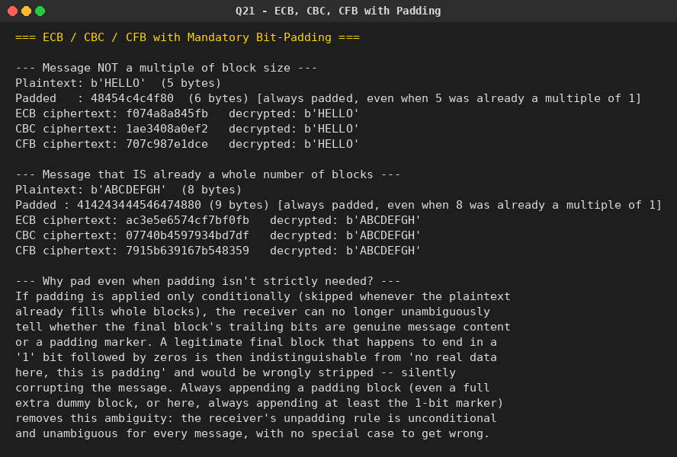

Question 22: CBC Mode Encryption/Decryption using S-DES
Problem: Write a C program to encrypt and decrypt in cipher block chaining mode using S-DES. Test data: binary IV = 1010 1010; binary plaintext 0000 0001 0010 0011 encrypted with binary key 01111 11101 should give binary ciphertext 1111 0100 0000 1011. Decryption should work correspondingly.
Python Program:
# Q22. Encrypt and decrypt in Cipher Block Chaining (CBC) mode using S-DES
# (Simplified DES) as the underlying 8-bit block cipher.
#
# Test vector (from the assignment):
# IV = 1010 1010
# Plaintext = 0000 0001 0010 0011
# Key = 01111 11101 (10 bits)
# Expected ciphertext = 1111 0100 0000 1011

from sdes import (
sdes_encrypt_block, sdes_decrypt_block, bitstr_to_list, list_to_bitstr, xor
)

def cbc_encrypt(plain_blocks, key, iv):
prev = iv
cipher_blocks = []
for p in plain_blocks:
c = sdes_encrypt_block(xor(p, prev), key)
cipher_blocks.append(c)
prev = c
return cipher_blocks

def cbc_decrypt(cipher_blocks, key, iv):
prev = iv
plain_blocks = []
for c in cipher_blocks:
p = xor(sdes_decrypt_block(c, key), prev)
plain_blocks.append(p)
prev = c
return plain_blocks

def split_into_bytes(bitstring):
bits = bitstring.replace(" ", "")
return [bitstr_to_list(bits[i:i + 8]) for i in range(0, len(bits), 8)]

if __name__ == "__main__":
print("=== CBC Mode Encryption/Decryption using S-DES ===\n")

key = bitstr_to_list("0111111101")
iv = bitstr_to_list("10101010")
plaintext_blocks = split_into_bytes("0000000100100011")

print(f"Key (10 bits): {list_to_bitstr(key, group=5)}")
print(f"IV (8 bits) : {list_to_bitstr(iv)}")
print("Plaintext blocks:", [list_to_bitstr(b) for b in plaintext_blocks])

ciphertext_blocks = cbc_encrypt(plaintext_blocks, key, iv)
print("\nCiphertext blocks:", [list_to_bitstr(b) for b in ciphertext_blocks])
print("Expected : ['1111 0100', '0000 1011']")
matches = [list_to_bitstr(c) for c in ciphertext_blocks] == ["1111 0100", "0000 1011"]
print(f"Matches expected test vector: {matches}")

decrypted_blocks = cbc_decrypt(ciphertext_blocks, key, iv)
print("\nDecrypted blocks :", [list_to_bitstr(b) for b in decrypted_blocks])
print(f"Round-trip correct: {decrypted_blocks == plaintext_blocks}")

# --- Also demonstrate on a text message, to show general use ---
print("\n--- General demonstration with a text message ---")
message = "HI!"
msg_bits = ''.join(f'{ord(c):08b}' for c in message)
msg_blocks = [bitstr_to_list(msg_bits[i:i + 8]) for i in range(0, len(msg_bits), 8)]

demo_key = bitstr_to_list("1010000010")
demo_iv = bitstr_to_list("01010101")

demo_cipher = cbc_encrypt(msg_blocks, demo_key, demo_iv)
demo_plain = cbc_decrypt(demo_cipher, demo_key, demo_iv)

recovered_text = ''.join(
chr(int(''.join(map(str, b)), 2)) for b in demo_plain
)
print(f"Message : {message!r}")
print(f"Ciphertext blocks: {[list_to_bitstr(b) for b in demo_cipher]}")
print(f"Recovered : {recovered_text!r} (matches original: {recovered_text == message})")

Output:
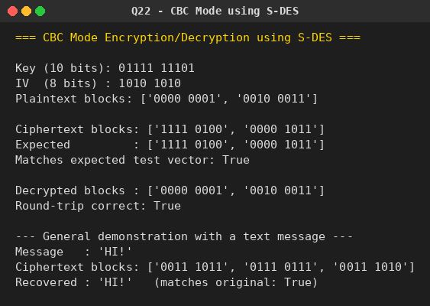

Question 23: Counter (CTR) Mode Encryption/Decryption using S-DES
Problem: Write a C program to encrypt and decrypt in counter mode using S-DES. Test data: counter starting at 0000 0000; binary plaintext 0000 0001 0000 0010 0000 0100 encrypted with binary key 01111 11101 should give binary ciphertext 0011 1000 0100 1111 0011 0010. Decryption should work correspondingly.
Python Program:
# Q23. Encrypt and decrypt in Counter (CTR) mode using S-DES as the
# underlying 8-bit block cipher.
#
# CTR mode: C_i = P_i XOR E_K(counter_i) counter increments each block
# P_i = C_i XOR E_K(counter_i) (same keystream, so decryption
# uses the identical operation)
#
# Test vector (from the assignment):
# Counter starts at 0000 0000
# Plaintext = 0000 0001 0000 0010 0000 0100
# Key = 01111 11101
# Expected ciphertext = 0011 1000 0100 1111 0011 0010

from sdes import sdes_encrypt_block, bitstr_to_list, list_to_bitstr, xor

def increment_counter(counter_bits):
val = int(''.join(map(str, counter_bits)), 2)
val = (val + 1) % (2 ** len(counter_bits))
return [int(b) for b in format(val, f'0{len(counter_bits)}b')]

def ctr_encrypt(plain_blocks, key, counter_start):
counter = list(counter_start)
out = []
for p in plain_blocks:
keystream = sdes_encrypt_block(counter, key)
out.append(xor(p, keystream))
counter = increment_counter(counter)
return out

def ctr_decrypt(cipher_blocks, key, counter_start):
# CTR decryption is identical to encryption -- XOR with the same keystream.
return ctr_encrypt(cipher_blocks, key, counter_start)

def split_into_bytes(bitstring):
bits = bitstring.replace(" ", "")
return [bitstr_to_list(bits[i:i + 8]) for i in range(0, len(bits), 8)]

if __name__ == "__main__":
print("=== Counter (CTR) Mode Encryption/Decryption using S-DES ===\n")

key = bitstr_to_list("0111111101")
counter0 = bitstr_to_list("00000000")
plaintext_blocks = split_into_bytes("000000010000001000000100")

print(f"Key (10 bits) : {list_to_bitstr(key, group=5)}")
print(f"Counter start : {list_to_bitstr(counter0)}")
print("Plaintext blocks:", [list_to_bitstr(b) for b in plaintext_blocks])

ciphertext_blocks = ctr_encrypt(plaintext_blocks, key, counter0)
print("\nCiphertext blocks:", [list_to_bitstr(b) for b in ciphertext_blocks])
print("Expected : ['0011 1000', '0100 1111', '0011 0010']")
matches = [list_to_bitstr(c) for c in ciphertext_blocks] == \
["0011 1000", "0100 1111", "0011 0010"]
print(f"Matches expected test vector: {matches}")

decrypted_blocks = ctr_decrypt(ciphertext_blocks, key, counter0)
print("\nDecrypted blocks :", [list_to_bitstr(b) for b in decrypted_blocks])
print(f"Round-trip correct: {decrypted_blocks == plaintext_blocks}")

print("\n--- General demonstration with a text message ---")
message = "OK!"
msg_bits = ''.join(f'{ord(c):08b}' for c in message)
msg_blocks = [bitstr_to_list(msg_bits[i:i + 8]) for i in range(0, len(msg_bits), 8)]

demo_key = bitstr_to_list("1010000010")
demo_counter0 = bitstr_to_list("00000000")

demo_cipher = ctr_encrypt(msg_blocks, demo_key, demo_counter0)
demo_plain = ctr_decrypt(demo_cipher, demo_key, demo_counter0)

recovered_text = ''.join(
chr(int(''.join(map(str, b)), 2)) for b in demo_plain
)
print(f"Message : {message!r}")
print(f"Ciphertext blocks: {[list_to_bitstr(b) for b in demo_cipher]}")
print(f"Recovered : {recovered_text!r} (matches original: {recovered_text == message})")

print("\nNote: CTR mode turns a block cipher into a stream cipher; encryption")
print("and decryption are the identical XOR-with-keystream operation, and each")
print("block can be processed independently and in parallel (unlike CBC).")

Output:
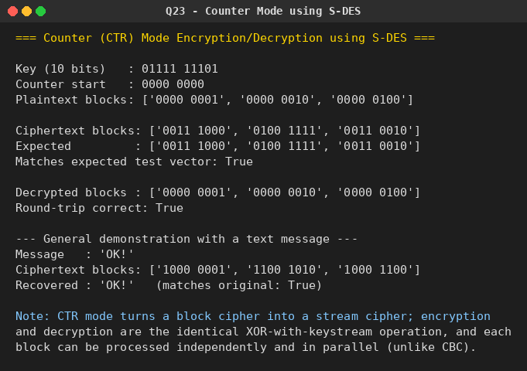

Question 24: RSA Private Key Recovery
Problem: Write a C program for the RSA system: the public key of a given user is e = 31, n = 3599. What is the private key of this user? Hint: first use trial-and-error to determine p and q, then use the extended Euclidean algorithm to find the multiplicative inverse of 31 modulo phi(n).
Python Program:
# Q24. Given the public key (e=31, n=3599), find the private key d.
# 1. Factor n = p * q by trial division (n is small enough here).
# 2. Compute phi(n) = (p-1)(q-1).
# 3. Use the Extended Euclidean Algorithm to find d = e^-1 mod phi(n).

def factor_n(n):
p = 2
while p * p <= n:
if n % p == 0:
return p, n // p
p += 1
return None, None

def extended_gcd(a, b):
if b == 0:
return a, 1, 0
g, x1, y1 = extended_gcd(b, a % b)
x, y = y1, x1 - (a // b) * y1
return g, x, y

def mod_inverse(e, phi):
g, x, _ = extended_gcd(e, phi)
if g != 1:
return None # inverse doesn't exist
return x % phi

if __name__ == "__main__":
print("=== Recovering an RSA Private Key from the Public Key ===\n")

e, n = 31, 3599
print(f"Public key: e = {e}, n = {n}")

p, q = factor_n(n)
print(f"\nStep 1 - Factor n by trial division: n = {p} x {q}")

phi = (p - 1) * (q - 1)
print(f"Step 2 - phi(n) = (p-1)(q-1) = ({p}-1)({q}-1) = {phi}")

d = mod_inverse(e, phi)
print(f"Step 3 - Extended Euclidean Algorithm: d = e^-1 mod phi(n) = {d}")

print(f"\nPrivate key: d = {d} (with n = {n})")

# Sanity check: e*d mod phi(n) should be 1, and encrypt/decrypt should round-trip.
print(f"\nVerification: (e * d) mod phi(n) = {(e * d) % phi} (should be 1)")

m = 12345 % n # any sample message < n
c = pow(m, e, n)
recovered = pow(c, d, n)
print(f"\nSample message m = {m}")
print(f"Encrypted c = m^e mod n = {c}")
print(f"Decrypted m'= c^d mod n = {recovered}")
print(f"Round-trip correct: {recovered == m}")

Output:
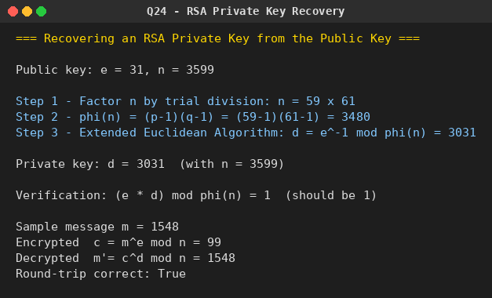

Question 25: RSA: Does a Plaintext Block Sharing a Factor with n Help an Attacker?
Problem: We have a set of blocks encoded with the RSA algorithm and we don't have the private key. Assume n = pq, e is the public key. Suppose someone tells us they know one of the plaintext blocks has a common factor with n. Does this help us in any way?
Python Program:
# Q25. We have RSA-encoded blocks and do NOT know the private key. n = p*q,
# e is public. Someone tells us that one of the PLAINTEXT blocks shares a
# common factor with n. Does this help us?
#
# YES -- decisively. If a plaintext block m satisfies 0 < m < n and
# gcd(m, n) != 1, then since n = p*q with p, q prime, the only possible
# nontrivial common factor of m and n is p or q itself. Computing
# gcd(m, n) via the Euclidean algorithm (fast, no factoring needed)
# immediately reveals that prime factor -- and from a single prime factor
# of n, phi(n) and the entire private key d can be reconstructed. So this
# single piece of information breaks RSA completely for this user, for
# EVERY ciphertext -- not just the block in question.
#
# This program demonstrates the attack end-to-end.

import math

def extended_gcd(a, b):
if b == 0:
return a, 1, 0
g, x1, y1 = extended_gcd(b, a % b)
x, y = y1, x1 - (a // b) * y1
return g, x, y

def mod_inverse(e, phi):
g, x, _ = extended_gcd(e, phi)
if g != 1:
return None
return x % phi

if __name__ == "__main__":
print("=== RSA: Exploiting a Plaintext Block that Shares a Factor with n ===\n")

# Set up an RSA keypair the "attacker" does NOT know p, q, or d for.
p, q = 9973, 10007 # two primes (kept secret from the attacker in this scenario)
n = p * q
phi = (p - 1) * (q - 1)
e = 65537
d = mod_inverse(e, phi)

print(f"(setup, unknown to attacker) p = {p}, q = {q}")
print(f"Public key: e = {e}, n = {n}\n")

# Suppose one of the intercepted plaintext blocks happens to be a multiple of q
# (this is the "common factor with n" scenario described in the question).
secret_plaintext_block = q * 7 # shares factor q with n, still < n
ciphertext_block = pow(secret_plaintext_block, e, n)

print(f"Intercepted ciphertext block: {ciphertext_block}")
print("We are TOLD (but do not directly see) that its plaintext block")
print(f"shares a common factor with n. (unknown to attacker: plaintext = {secret_plaintext_block})\n")

print("--- The attack ---")
print("Step 1: We don't know the plaintext block's value outright, but suppose")
print(" we can obtain/guess it (e.g. via a side channel, weak padding,")
print(" or it is simply revealed to us as in this problem). Call it m.")
m = secret_plaintext_block
print(f" m = {m}")

g = math.gcd(m, n)
print(f"\nStep 2: Compute gcd(m, n) using the Euclidean algorithm (FAST -- no")
print(f" factoring of n required): gcd({m}, {n}) = {g}")

if g != 1 and g != n:
recovered_p_or_q = g
other_factor = n // g
print(f"\nStep 3: Since n = p*q for primes p,q, and 1 < gcd(m,n) < n, this gcd")
print(f" MUST be one of the two prime factors of n.")
print(f" Recovered factor: {recovered_p_or_q}")
print(f" Other factor (n / recovered): {other_factor}")

recovered_phi = (recovered_p_or_q - 1) * (other_factor - 1)
recovered_d = mod_inverse(e, recovered_phi)

print(f"\nStep 4: phi(n) = (p-1)(q-1) = {recovered_phi}")
print(f" Recovered private key d = {recovered_d}")
print(f" Matches true private key: {recovered_d == d}")

# Now decrypt a DIFFERENT ciphertext block using the recovered key,
# to show the whole system -- not just this one block -- is broken.
other_message = 424242
other_cipher = pow(other_message, e, n)
decrypted_with_recovered_key = pow(other_cipher, recovered_d, n)
print(f"\nStep 5: Using the recovered private key on a DIFFERENT, unrelated")
print(f" ciphertext block ({other_cipher}):")
print(f" Decrypted result: {decrypted_with_recovered_key}")
print(f" Correct: {decrypted_with_recovered_key == other_message}")

print("\n--- Conclusion ---")
print("Yes, this helps enormously. A plaintext block that shares a factor with n")
print("lets us recover a prime factor of n via a single, cheap gcd computation")
print("(polynomial time), instead of factoring n from scratch (believed to be")
print("computationally hard for large n). Once one prime factor is known, phi(n)")
print("and the full private key d follow immediately -- breaking RSA completely")
print("for this user, for ALL of their ciphertexts, not just the one block that")
print("happened to share the factor. This is exactly why textbook RSA requires")
print("padding schemes (e.g. OAEP) that make plaintext blocks effectively random")
print("and vanishingly unlikely to share a nontrivial factor with n by chance.")

Output:
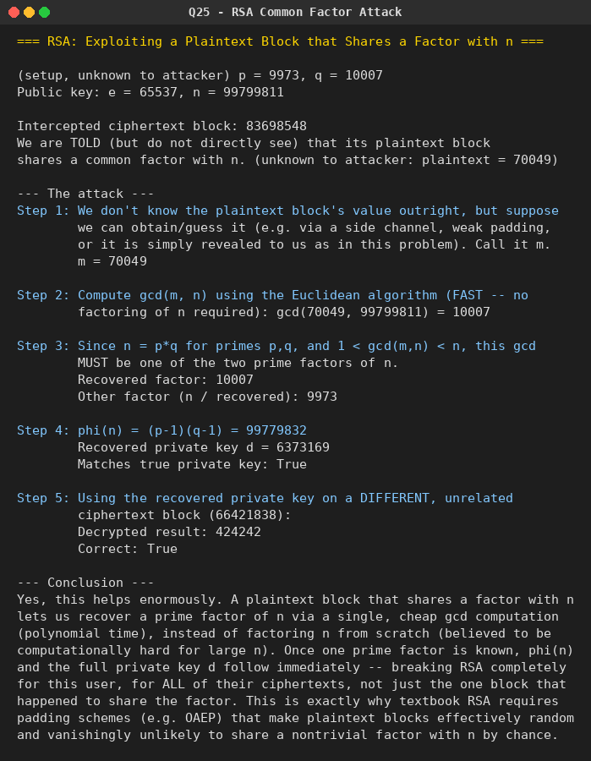

Question 26: RSA: Is Reusing n After a Private-Key Leak Safe?
Problem: Each user has a public key e and a private key d. Suppose Bob leaks his private key. Rather than generating a new modulus, he decides to generate a new public and a new private key. Is this safe?
Python Program:
# Q26. Bob's RSA private key d leaks. Instead of generating a fresh modulus n,
# he keeps the same n and generates a new (e', d') pair. Is this safe?
#
# NO. There is a well-known probabilistic polynomial-time algorithm that,
# given ANY valid (e, d, n) triple (i.e. any matching public/private
# exponent pair for that modulus), factors n completely -- WITHOUT trial
# division. Once n = p*q is known, an attacker can compute phi(n) and hence
# derive the private key matching ANY public key that uses that same n,
# including Bob's brand new (e', d'). So simply rotating the exponent while
# keeping n is not safe -- the modulus itself must be regenerated.
#
# This program implements that factoring algorithm and demonstrates the
# attack end-to-end.

import random
random.seed(1234)

def mod_inverse(e, phi):
def extended_gcd(a, b):
if b == 0:
return a, 1, 0
g, x1, y1 = extended_gcd(b, a % b)
return g, y1, x1 - (a // b) * y1
g, x, _ = extended_gcd(e, phi)
return x % phi if g == 1 else None

def factor_from_exponents(n, e, d):
"""Given a valid (e, d) pair for modulus n, factor n.
Standard algorithm: k = e*d - 1 is a multiple of phi(n), hence a multiple
of the order of every element mod n. Write k = 2^s * t (t odd). For
random bases a, the sequence a^t, a^(2t), ... a^(2^(s-1) t) mod n will,
with probability >= 1/2, hit a nontrivial square root of 1 mod n -- and
any such root x (x != +-1 mod n, x^2 == 1 mod n) gives gcd(x-1, n) as a
nontrivial factor of n.
"""
k = e * d - 1
s = 0
t = k
while t % 2 == 0:
t //= 2
s += 1

for _ in range(200): # attempts with random bases
a = random.randrange(2, n - 1)
x = pow(a, t, n)
if x == 1 or x == n - 1:
continue
for _ in range(s - 1):
y = pow(x, 2, n)
if y == 1:
# x is a nontrivial square root of 1 -> factor found
p = gcd(x - 1, n)
if p != 1 and p != n:
return p, n // p
if y == n - 1:
break
x = y
return None, None

def gcd(a, b):
while b:
a, b = b, a % b
return a

if __name__ == "__main__":
print("=== Is Rotating (e, d) While Reusing n Safe After a Private-Key Leak? ===\n")

# Set up Bob's ORIGINAL keypair (unknown p, q to the attacker in principle,
# but the attacker HAS learned d because it leaked).
p, q = 10007, 10039
n = p * q
phi = (p - 1) * (q - 1)
e = 65537
d = mod_inverse(e, phi)

print(f"(Bob's original keypair, p and q secret) n = {n}")
print(f"Bob's original public key : e = {e}")
print(f"Bob's original private key: d = {d} <-- THIS LEAKED\n")

print("Attacker uses the leaked (e, d, n) to factor n (no brute force needed):")
recovered_p, recovered_q = factor_from_exponents(n, e, d)
print(f" Recovered factors: p = {recovered_p}, q = {recovered_q}")
print(f" Correct factorization: {sorted((recovered_p, recovered_q)) == sorted((p, q))}\n")

# Bob "fixes" the problem by keeping n but generating a NEW keypair.
e2 = 17
d2 = mod_inverse(e2, phi)
print(f"Bob generates a NEW public/private keypair but reuses the same n:")
print(f" New public key : e' = {e2}")
print(f" New private key: d' = {d2} (Bob believes this is now safe)\n")

print("But the attacker already knows n's factorization (p, q) from the leak,")
print("so phi(n) is trivial to recompute, and the attacker derives d' directly")
print("from the PUBLIC e' -- no new leak needed:")
recovered_phi = (recovered_p - 1) * (recovered_q - 1)
forged_d2 = mod_inverse(e2, recovered_phi)
print(f" Attacker-derived d' = {forged_d2}")
print(f" Matches Bob's real new private key: {forged_d2 == d2}\n")

print("--- Conclusion ---")
print("NOT SAFE. Leaking even one valid (e, d) pair for a modulus n lets an")
print("attacker factor n efficiently. Once n is factored, EVERY current and")
print("future keypair that reuses that same n is instantly broken -- rotating")
print("only the exponent accomplishes nothing. Bob must generate a brand-new")
print("modulus n (i.e. new primes p, q) to actually recover security.")

Output:
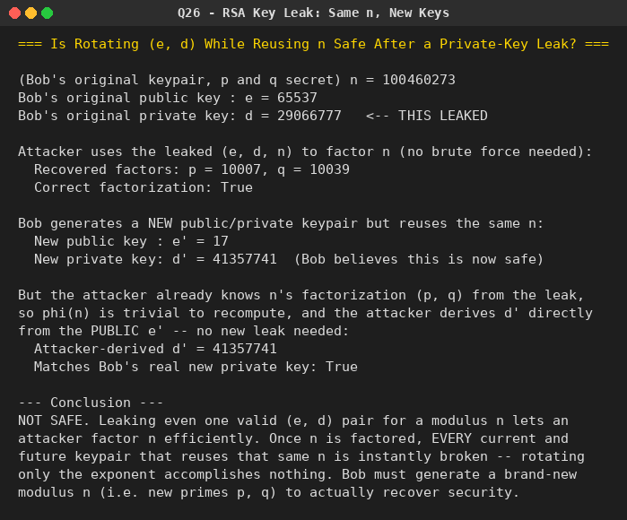

Question 27: RSA: Encrypting Single Alphabetic Characters (A=0..Z=25)
Problem: Bob uses RSA with a very large modulus n for which the factorization cannot be found in a reasonable amount of time. Alice represents each alphabetic character as an integer between 0 and 25 (A=0, ..., Z=25) and encrypts each number separately using RSA with large e and large n. Is this method secure? If not, describe the most efficient attack against this encryption method.
Python Program:
# Q27. Alice encrypts each alphabetic character (A=0 .. Z=25) SEPARATELY with
# RSA, using a very large e and n (large enough that factoring n is
# infeasible). Is this secure?
#
# NO -- regardless of how large e and n are. Plain (textbook) RSA is
# DETERMINISTIC: the same plaintext integer always encrypts to the same
# ciphertext under a given public key. Since there are only 26 possible
# plaintext values (0..25), an attacker who knows Bob's PUBLIC key can
# simply precompute c = m^e mod n for all 26 letters ONE TIME, building a
# lookup table, and then instantly reverse any intercepted ciphertext by
# table lookup -- no factoring of n, and no private key, ever required.
# This is a chosen/known-plaintext attack that is devastating specifically
# because the plaintext space is tiny, independent of key size.

import random

def is_probable_prime(n, k=20):
if n < 2:
return False
for p in [2, 3, 5, 7, 11, 13, 17, 19, 23, 29, 31]:
if n % p == 0:
return n == p
d, r = n - 1, 0
while d % 2 == 0:
d //= 2
r += 1
for _ in range(k):
a = random.randrange(2, n - 1)
x = pow(a, d, n)
if x == 1 or x == n - 1:
continue
for _ in range(r - 1):
x = pow(x, 2, n)
if x == n - 1:
break
else:
return False
return True

def random_prime(bits):
while True:
candidate = random.getrandbits(bits) | (1 << (bits - 1)) | 1
if is_probable_prime(candidate):
return candidate

def mod_inverse(e, phi):
def extended_gcd(a, b):
if b == 0:
return a, 1, 0
g, x1, y1 = extended_gcd(b, a % b)
return g, y1, x1 - (a // b) * y1
g, x, _ = extended_gcd(e, phi)
return x % phi if g == 1 else None

def short(num, head=10, tail=6):
s = str(num)
if len(s) <= head + tail + 3:
return s
return f"{s[:head]}...{s[-tail:]} ({len(s)} digits)"

if __name__ == "__main__":
random.seed(7)
print("=== Is Per-Character RSA (A=0..Z=25) Secure, Even with Huge e, n? ===\n")

# Generate a genuinely large RSA keypair (512-bit primes -> 1024-bit n).
p = random_prime(512)
q = random_prime(512)
n = p * q
phi = (p - 1) * (q - 1)
e = 65537
d = mod_inverse(e, phi)

print(f"n has {n.bit_length()} bits (large, factoring is NOT feasible)")
print(f"Public key: e = {e}\n")

# Alice encrypts a secret word letter-by-letter.
secret_word = "ATTACK"
plain_values = [ord(c) - ord('A') for c in secret_word]
ciphertexts = [pow(m, e, n) for m in plain_values]

print(f"Alice's secret message: {secret_word!r}")
print(f"Per-letter plaintext integers: {plain_values}")
print(f"Intercepted ciphertexts (Eve does NOT have the private key):")
for c in ciphertexts:
print(f" {short(c)}")

print("\n--- The attack (Eve, using ONLY the public key e, n) ---")
print("Step 1: Precompute the encryption of every possible letter, ONCE:")
lookup_table = {}
for letter_val in range(26):
c = pow(letter_val, e, n)
lookup_table[c] = letter_val
print(f" Built a table of all {len(lookup_table)} possible ciphertexts "
f"(for m = 0..25) under the PUBLIC key.")

print("\nStep 2: For each intercepted ciphertext, look up the matching plaintext:")
recovered_values = [lookup_table[c] for c in ciphertexts]
recovered_word = ''.join(chr(v + ord('A')) for v in recovered_values)
print(f" Recovered letters: {recovered_values}")
print(f" Recovered word : {recovered_word!r}")
print(f" Matches original : {recovered_word == secret_word}")

print("\n--- Conclusion ---")
print("This method is NOT secure, no matter how large e and n are. The")
print("vulnerability has nothing to do with breaking RSA's math -- it comes")
print("entirely from encrypting a message drawn from a tiny plaintext space")
print("(26 possible values) with a DETERMINISTIC cipher. The fix is standard")
print("RSA padding (e.g. OAEP), which randomizes each encryption so the same")
print("plaintext produces a different ciphertext every time, and/or combining")
print("many characters into one large block instead of encrypting them one at a time.")

Output:
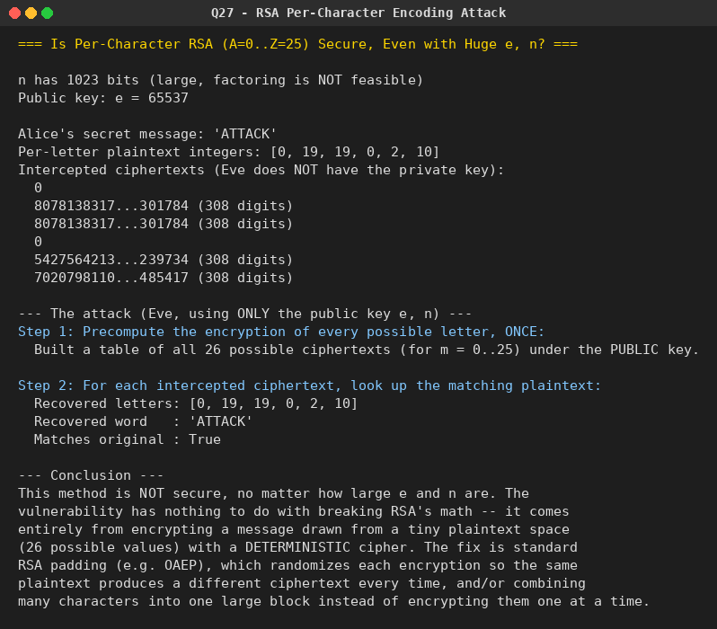

Question 28: Diffie-Hellman with Multiplication Instead of Exponentiation
Problem: In Diffie-Hellman, each participant selects a secret number x and sends the other participant a^x mod q for some public number a. What would happen if the participants sent each other x*a for some public number a instead? Give at least one method Alice and Bob could use to agree on a key. Can Eve break your system without finding the secret numbers? Can Eve find the secret numbers?
Python Program:
# Q28. Standard Diffie-Hellman: each side picks secret x, sends a^x mod q.
# What if, instead, each side sent (a * x) mod q (multiplication instead of
# modular EXPONENTIATION)?
#
# Modular exponentiation is a one-way function (computing a^x mod q is easy;
# recovering x from a^x mod q -- the discrete log problem -- is believed
# hard for well-chosen groups). Modular MULTIPLICATION by a known constant a
# is NOT one-way: it is trivially invertible whenever gcd(a, q) = 1, simply
# by multiplying by a's modular inverse. This program demonstrates exactly
# how badly that breaks the protocol.

import random
random.seed(42)

def extended_gcd(a, b):
if b == 0:
return a, 1, 0
g, x1, y1 = extended_gcd(b, a % b)
return g, y1, x1 - (a // b) * y1

def mod_inverse(a, m):
g, x, _ = extended_gcd(a, m)
if g != 1:
return None
return x % m

if __name__ == "__main__":
print("=== 'Diffie-Hellman' Using Multiplication Instead of Exponentiation ===\n")

q = 104729 # a public prime modulus
a = 17 # a public base, gcd(a, q) = 1 since q is prime and a < q

print(f"Public parameters: q = {q}, a = {a}\n")

# Alice and Bob each pick a secret number and broadcast a*x mod q.
x_A = random.randrange(2, q - 1)
x_B = random.randrange(2, q - 1)

Y_A = (a * x_A) % q # what Alice broadcasts publicly
Y_B = (a * x_B) % q # what Bob broadcasts publicly

print(f"Alice's secret x_A = {x_A} -> broadcasts Y_A = (a * x_A) mod q = {Y_A}")
print(f"Bob's secret x_B = {x_B} -> broadcasts Y_B = (a * x_B) mod q = {Y_B}\n")

print("--- A method Alice and Bob could try, to agree on a shared key ---")
print("By analogy with real DH (where the shared secret is (a^x_A)^x_B = a^(x_A*x_B)),")
print("here the natural analogue is to have each side apply their OWN secret to the")
print("value they received, the same way:")
K_from_Alice = (x_A * Y_B) % q # Alice computes x_A * Y_B mod q
K_from_Bob = (x_B * Y_A) % q # Bob computes x_B * Y_A mod q
print(f" Alice computes K = (x_A * Y_B) mod q = {K_from_Alice}")
print(f" Bob computes K = (x_B * Y_A) mod q = {K_from_Bob}")
print(f" Do they agree? {K_from_Alice == K_from_Bob} "
f"(mod q, x_A*x_B*a mod q is the same either way -- multiplication is commutative)\n")

print("--- Can Eve break the system WITHOUT finding the secret numbers x_A, x_B? ---")
print("YES -- trivially. Eve, who only observes the public values a, q, Y_A, Y_B,")
print("can compute the exact same shared key HERSELF, using nothing but public data,")
print("because the 'combine' operation is just multiplication (commutative/associative)")
print("and does not actually require knowing x_A or x_B individually:")
a_inv = mod_inverse(a, q)
eve_K = (Y_A * Y_B * a_inv) % q
print(f" Eve computes: K_eve = (Y_A * Y_B * a^-1) mod q = {eve_K}")
print(f" Matches the real shared key: {eve_K == K_from_Alice}\n")

print("--- Can Eve find the secret numbers x_A, x_B themselves? ---")
print("YES -- also trivially, because modular multiplication by the public constant")
print("'a' is easily inverted (unlike modular exponentiation, which is a one-way")
print("function under the discrete-log assumption). Eve simply multiplies by the")
print("modular inverse of a:")
recovered_xA = (Y_A * a_inv) % q
recovered_xB = (Y_B * a_inv) % q
print(f" a^-1 mod q = {a_inv}")
print(f" Recovered x_A = (Y_A * a^-1) mod q = {recovered_xA} (real x_A = {x_A})")
print(f" Recovered x_B = (Y_B * a^-1) mod q = {recovered_xB} (real x_B = {x_B})")
print(f" Both recovered correctly: {recovered_xA == x_A and recovered_xB == x_B}\n")

print("--- Conclusion ---")
print("This 'multiplicative Diffie-Hellman' provides NO security whatsoever.")
print("Everything (the shared key AND both parties' secret numbers) is recoverable")
print("by any passive eavesdropper using only public information and basic modular")
print("arithmetic. The security of real Diffie-Hellman depends entirely on modular")
print("EXPONENTIATION being a one-way function (hard discrete log); modular")
print("multiplication by a known constant has no such one-wayness at all.")

Output:
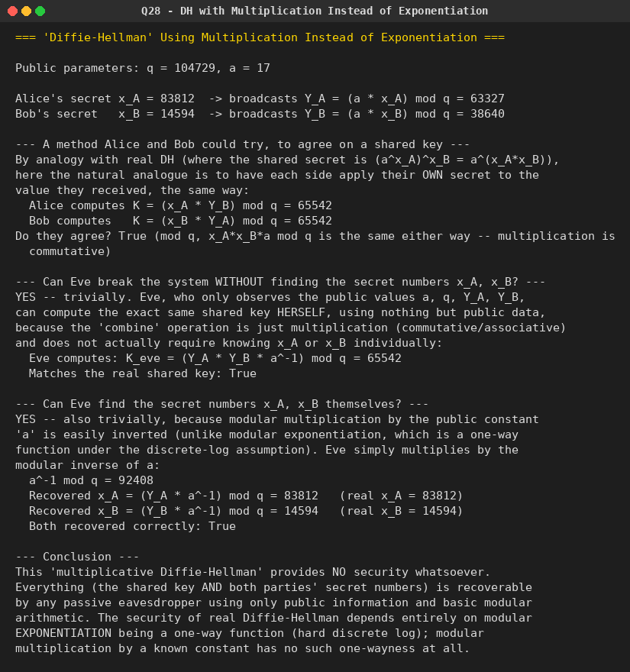

Question 29: SHA-3: Capacity Lane Diffusion
Problem: For a SHA-3 option with a block size of 1024 bits, assume each of the lanes in the first message block (P0) has at least one nonzero bit. Initially, all lanes in the internal state matrix corresponding to the capacity portion are zero. Show how long it will take before all of these lanes have at least one nonzero bit. (Ignore the permutation's other mixing steps; keep track of the original zero lanes even after they change position.)
Python Program:
# Q29. SHA-3 (Keccak) sponge, block(rate) size r = 1024 bits.
# The full state is b = 1600 bits, arranged as a 5x5 grid of w = 64-bit
# "lanes" (25 lanes total). r/w = 1024/64 = 16 lanes belong to the RATE
# (message is XORed into these); the remaining b/w - r/w = 25 - 16 = 9
# lanes belong to the CAPACITY, and all start out as all-zero.
#
# Given: every lane of the first message block P0 has at least one nonzero
# bit, so immediately after absorbing P0, all 16 rate lanes are nonzero and
# all 9 capacity lanes are still exactly zero.
#
# As instructed, we ignore theta/chi/iota (the steps that actually mix bits
# between lanes) and track ONLY the lane-relocation caused by the pi step
# (rho only rotates bits *within* a lane, so it can never turn a zero lane
# into a nonzero one or vice versa -- it doesn't change which lanes are
# nonzero, only bit positions inside them). So a lane's "has >=1 nonzero
# bit" property is preserved as pi moves it to a new grid position each
# round. We ask: after how many applications of pi does every one of the
# (fixed) 9 capacity-lane positions end up having held a nonzero lane at
# least once?

W = 64 # bits per lane
B = 1600 # total state size (bits) for standard Keccak-f[1600]
R = 1024 # rate (block) size in bits, as specified by the question
LANES_TOTAL = B // W # 25
RATE_LANES = R // W # 16
CAPACITY_LANES = LANES_TOTAL - RATE_LANES # 9

def lane_index(x, y):
return x + 5 * y # standard Keccak linear lane numbering

def pi_step(grid):
"""FIPS 202 pi step: new[x][y] = old[(x+3y) mod 5][x]."""
new_grid = [[False] * 5 for _ in range(5)]
for x in range(5):
for y in range(5):
new_grid[x][y] = grid[(x + 3 * y) % 5][x]
return new_grid

if __name__ == "__main__":
print("=== SHA-3 (r = 1024 bits): How Fast Do Capacity Lanes Become Nonzero? ===\n")
print(f"Total lanes (b/w) : {LANES_TOTAL}")
print(f"Rate lanes (r/w) : {RATE_LANES} (message-absorbing lanes)")
print(f"Capacity lanes : {CAPACITY_LANES} (start all-zero)\n")

# Build initial 5x5 grid of "is this lane nonzero?" flags.
# Rate lanes occupy linear indices 0..RATE_LANES-1 (fixed positions,
# per the standard Keccak state serialization).
grid = [[False] * 5 for _ in range(5)]
for x in range(5):
for y in range(5):
if lane_index(x, y) < RATE_LANES:
grid[x][y] = True # nonzero after absorbing P0

capacity_positions = [(x, y) for x in range(5) for y in range(5)
if lane_index(x, y) >= RATE_LANES]

print(f"Capacity lane positions (x,y): {capacity_positions}\n")

touched = {pos: False for pos in capacity_positions}
round_num = 0

print("Round | nonzero-lane positions currently in the CAPACITY area")
while not all(touched.values()):
round_num += 1
grid = pi_step(grid)
currently_nonzero_capacity = [pos for pos in capacity_positions if grid[pos[0]][pos[1]]]
for pos in currently_nonzero_capacity:
touched[pos] = True
print(f"{round_num:5d} | {currently_nonzero_capacity} "
f"(touched so far: {sum(touched.values())}/{CAPACITY_LANES})")
if round_num > 50:
print("(stopping -- something unexpected, exceeded 50 rounds)")
break

print(f"\nAll {CAPACITY_LANES} capacity lanes have held a nonzero value at least once")
print(f"after {round_num} applications of the pi (lane-relocation) step.")

print("\nNote: this counts pure lane-permutation (pi) steps, per the question's")
print("instruction to ignore the other mixing steps (theta/chi/iota) that would")
print("normally accelerate diffusion considerably. In real Keccak-f[1600], pi is")
print("applied once per internal round (24 rounds total per permutation call),")
print(f"so this corresponds to needing only {round_num} of those 24 rounds' pi steps")
print("for full capacity coverage under this simplified (permutation-only) model.")

Output:
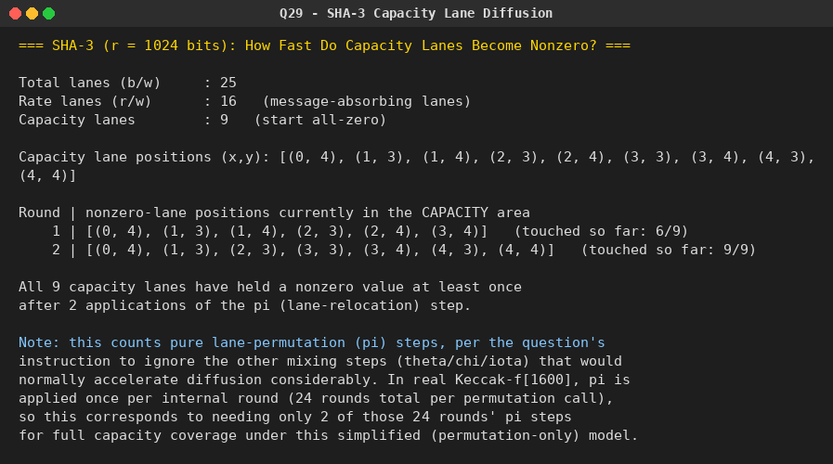

Question 30: CBC-MAC Forgery on a One-Block Message
Problem: Given the CBC MAC of a one-block message X, say T = MAC(K, X), show that the adversary immediately knows the CBC MAC for the two-block message X || (X XOR T), since this is once again T.
Python Program:
# Q30. Given the CBC-MAC of a ONE-block message X, i.e. T = MAC(K, X), an
# adversary can immediately compute the CBC-MAC of the TWO-block message
# X || (X XOR T) -- without knowing the key K -- and it equals the SAME
# tag T. This is the classic demonstration of why raw/basic CBC-MAC is
# insecure for variable-length messages (no length-binding or key
# separation between the last-block step and earlier steps).
#
# Basic (IV=0) CBC-MAC of a message M1, M2, ..., Mn:
# C0 = IV = 0
# C_i = E(K, M_i XOR C_{i-1})
# MAC = C_n (just the final block)
#
# For a one-block message X: T = E(K, X XOR 0) = E(K, X)
#
# For the two-block message M1 = X, M2 = X XOR T:
# C1 = E(K, X XOR 0) = E(K, X) = T (identical first step)
# C2 = E(K, M2 XOR C1) = E(K, (X XOR T) XOR T) = E(K, X) = T
# MAC = C2 = T -- SAME tag as the one-block message, with NO knowledge of K!

from Crypto.Cipher import AES
import os

def cbc_mac(key, blocks, block_size=16):
prev = bytes(block_size) # IV = 0
for block in blocks:
cipher = AES.new(key, AES.MODE_ECB)
prev = cipher.encrypt(bytes(a ^ b for a, b in zip(block, prev)))
return prev # tag = final ciphertext block

def xor_bytes(a, b):
return bytes(x ^ y for x, y in zip(a, b))

if __name__ == "__main__":
print("=== CBC-MAC Forgery: Extending a 1-Block Message for Free ===\n")

key = os.urandom(16)
X = os.urandom(16) # a one-block message (16 bytes for AES)

print(f"Key (attacker does NOT know this): {key.hex()}")
print(f"One-block message X: {X.hex()}\n")

T = cbc_mac(key, [X])
print(f"T = MAC(K, X) = {T.hex()} (attacker DOES see this tag)\n")

# Attacker, WITHOUT the key, constructs the forged two-block message.
forged_second_block = xor_bytes(X, T)
forged_message_blocks = [X, forged_second_block]
print("Attacker builds a two-block message: X || (X XOR T)")
print(f" Block 1 = X = {X.hex()}")
print(f" Block 2 = X XOR T = {forged_second_block.hex()}\n")

print("Attacker PREDICTS (without the key) that MAC(K, X || (X XOR T)) == T.")
print("Let's check by actually computing the true CBC-MAC (using the real key,")
print("which only the verifier/legitimate parties have) to confirm the forgery:")

actual_mac_of_forged_message = cbc_mac(key, forged_message_blocks)
print(f"\nActual MAC(K, X || (X XOR T)) = {actual_mac_of_forged_message.hex()}")
print(f"Original T = {T.hex()}")
print(f"Forgery successful (tags match): {actual_mac_of_forged_message == T}")

print("\n--- Why this matters ---")
print("An attacker who observes just ONE (message, tag) pair -- for ANY one-block")
print("message X -- can immediately produce a SECOND, different, valid message")
print("(X || X XOR T) with a KNOWN-VALID tag, without ever learning the secret key.")
print("This existential forgery is why raw CBC-MAC must never be used as-is on")
print("variable-length messages; real-world constructions fix this by prepending")
print("the message length, using a derived/whitened final-block key (as in CMAC),")
print("or using an unpredictable, non-attacker-controlled IV/key separation.")

Output:
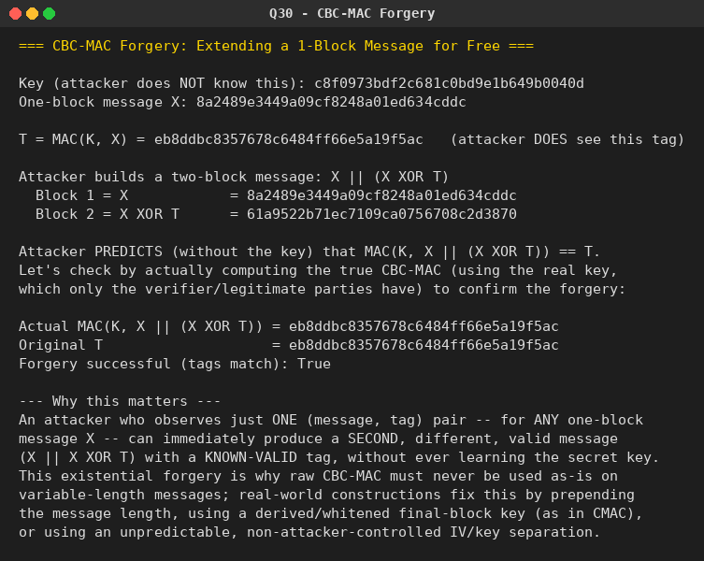

Question 31: CMAC Subkey Generation
Problem: In CMAC subkey generation, the block cipher is applied to the block consisting entirely of 0 bits. The first subkey is derived from the resulting string by a left shift of one bit and, conditionally, by XORing a constant that depends on the block size. The second subkey is derived the same way from the first. a. What constants are needed for block sizes of 64 and 128 bits? b. How do the left shift and XOR accomplish the desired result?
Python Program:
# Q31. CMAC subkey generation.
# 1. Apply the block cipher to the all-zero block: L = E(K, 0^b).
# 2. K1 = L << 1, and if the MSB of L was 1, XOR the result with a fixed
# constant Rb that depends on the block size b.
# 3. K2 = K1 << 1, XORed with Rb if the MSB of K1 was 1.
#
# a. What are the constants Rb for block sizes 64 and 128?
# b. Demonstrate/explain how the left-shift + conditional-XOR construction
# achieves the desired effect (multiplication by the polynomial "x" in
# GF(2^b), matching the field used by the block cipher's algebra).

from Crypto.Cipher import AES
import os

# Standard NIST SP 800-38B constants Rb, expressed as the low byte(s) of an
# otherwise-zero b-bit block (i.e. Rb is a specific low-degree polynomial
# in GF(2^b)'s standard representation).
RB_64 = 0x1B # for 64-bit block ciphers (e.g. DES, 3DES, S-DES conceptually)
RB_128 = 0x87 # for 128-bit block ciphers (e.g. AES)

def left_shift_1(data: bytes) -> bytes:
"""Shift an entire byte string left by 1 bit, returning (shifted_bytes, msb_that_fell_off)."""
n = len(data)
val = int.from_bytes(data, "big")
msb = (val >> (8 * n - 1)) & 1
shifted = (val << 1) & ((1 << (8 * n)) - 1)
return shifted.to_bytes(n, "big"), msb

def generate_subkeys(key: bytes, block_size_bytes: int, rb_constant: int):
zero_block = bytes(block_size_bytes)
cipher = AES.new(key, AES.MODE_ECB) if block_size_bytes == 16 else None
if cipher is None:
raise ValueError("This demo cipher only supports 128-bit (AES) blocks directly.")
L = cipher.encrypt(zero_block)

K1_shifted, msb1 = left_shift_1(L)
if msb1:
rb_bytes = rb_constant.to_bytes(block_size_bytes, "big")
K1 = bytes(a ^ b for a, b in zip(K1_shifted, rb_bytes))
else:
K1 = K1_shifted

K2_shifted, msb2 = left_shift_1(K1)
if msb2:
rb_bytes = rb_constant.to_bytes(block_size_bytes, "big")
K2 = bytes(a ^ b for a, b in zip(K2_shifted, rb_bytes))
else:
K2 = K2_shifted

return L, K1, K2, msb1, msb2

if __name__ == "__main__":
print("=== CMAC Subkey Generation ===\n")

print("--- a. Constants Rb needed for common block sizes ---")
print(f" Block size 64 bits (e.g. DES/3DES): Rb = 0x{RB_64:02X}"
f" (block = 0...0 01 1011, i.e. x^64 = x^4+x^3+x+1 reduction poly)")
print(f" Block size 128 bits (e.g. AES) : Rb = 0x{RB_128:02X}"
f" (block = 0...0 1000 0111, i.e. x^128 = x^7+x^2+x+1 reduction poly)\n")

key = os.urandom(16)
L, K1, K2, msb1, msb2 = generate_subkeys(key, 16, RB_128)

print("--- Worked example with a real 128-bit block cipher (AES) ---")
print(f"AES key : {key.hex()}")
print(f"L = E(K, 0^128) : {L.hex()}")
print(f"MSB of L is 1? : {bool(msb1)} -> "
f"{'XOR with Rb applied' if msb1 else 'no XOR needed'}")
print(f"K1 (first subkey) : {K1.hex()}")
print(f"MSB of K1 is 1? : {bool(msb2)} -> "
f"{'XOR with Rb applied' if msb2 else 'no XOR needed'}")
print(f"K2 (second subkey): {K2.hex()}\n")

print("--- b. Why left-shift + conditional-XOR works ---")
print("A b-bit block is treated as an element of the finite field GF(2^b),")
print("represented as a binary polynomial of degree < b. Left-shifting the")
print("block by 1 bit is exactly multiplication by the field element 'x'")
print("(i.e. by 2, in the integer analogy). If the top (most significant) bit")
print("was 0, the polynomial's degree was already < b after doubling, so the")
print("shifted value IS the correct product mod the field's irreducible")
print("reduction polynomial -- no further correction needed.")
print("If the top bit was 1, doubling would have produced a term of degree")
print("exactly b (the polynomial 'overflowed' out of the field), so we must")
print("reduce it modulo the field's fixed irreducible polynomial of degree b")
print("-- and XOR-ing with Rb (which directly encodes that reduction")
print("polynomial's lower-degree terms) performs exactly that modular")
print("reduction in one step. This is the identical 'multiply by x in")
print("GF(2^n), conditionally XOR the reduction constant' trick used in")
print("AES's MixColumns (xtime) and in GCM/GHASH -- CMAC reuses it to turn")
print("a single master key L into two distinct, algebraically related")
print("subkeys K1 = L*x and K2 = L*x^2 in the block cipher's field.")

Output:
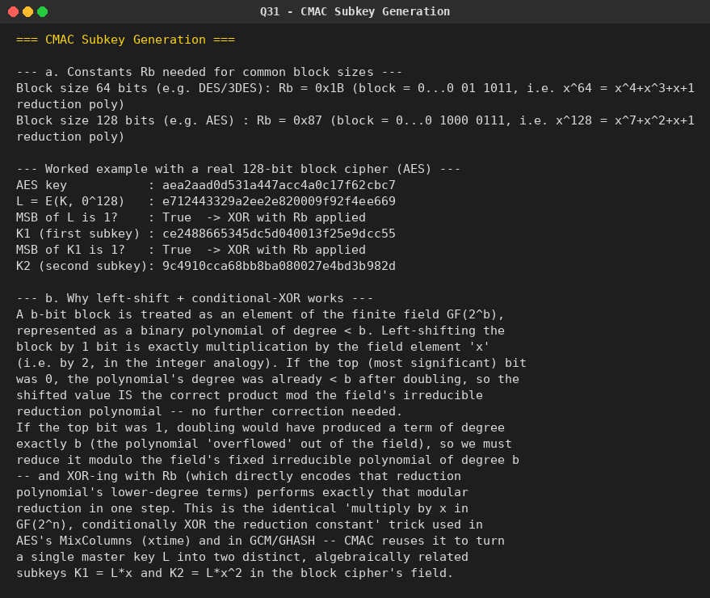

Question 32: DSA vs. RSA: Implication of Randomized Signatures
Problem: Because the value of k is generated fresh for each DSA signature, even signing the same message twice on different occasions produces different signatures. This is not true of RSA signatures. What is the implication of this difference?
Python Program:
# Q32. In DSA, a fresh random k is generated for EVERY signature, so signing
# the same message twice produces two DIFFERENT valid signatures. In RSA
# signing (textbook RSA signature = m^d mod n), there is no randomization,
# so signing the same message always gives the IDENTICAL signature. What
# does this difference imply?

import random

def extended_gcd(a, b):
if b == 0:
return a, 1, 0
g, x1, y1 = extended_gcd(b, a % b)
return g, y1, x1 - (a // b) * y1

def mod_inverse(a, m):
g, x, _ = extended_gcd(a, m)
return x % m if g == 1 else None

def is_prime(n, k=20):
if n < 2:
return False
for p in [2, 3, 5, 7, 11, 13, 17, 19, 23]:
if n % p == 0:
return n == p
d, r = n - 1, 0
while d % 2 == 0:
d //= 2
r += 1
for _ in range(k):
a = random.randrange(2, n - 1)
x = pow(a, d, n)
if x in (1, n - 1):
continue
for _ in range(r - 1):
x = pow(x, 2, n)
if x == n - 1:
break
else:
return False
return True

# --- tiny illustrative DSA-style scheme (small parameters for a lab demo;
# real DSA uses far larger q, p) ---
def dsa_demo():
q = 283 # small prime, illustrative only
while True:
k_mult = random.randint(2, 10)
p = k_mult * q + 1
if is_prime(p):
break
# find a generator g of the order-q subgroup
for h in range(2, p - 1):
g = pow(h, (p - 1) // q, p)
if g != 1:
break

x = random.randrange(2, q - 1) # private key
y = pow(g, x, p) # public key

def sign(msg_hash):
while True:
k = random.randrange(2, q - 1)
r = pow(g, k, p) % q
if r == 0:
continue
k_inv = mod_inverse(k, q)
if k_inv is None:
continue
s = (k_inv * (msg_hash + x * r)) % q
if s == 0:
continue
return r, s

def verify(msg_hash, r, s):
if not (0 < r < q and 0 < s < q):
return False
w = mod_inverse(s, q)
u1 = (msg_hash * w) % q
u2 = (r * w) % q
v = ((pow(g, u1, p) * pow(y, u2, p)) % p) % q
return v == r

return p, q, g, x, y, sign, verify

if __name__ == "__main__":
random.seed(3)
print("=== DSA: Randomized Signatures vs. RSA's Deterministic Signatures ===\n")

p, q, g, x, y, sign, verify = dsa_demo()
print(f"(tiny illustrative DSA parameters) p={p}, q={q}, g={g}")
print(f"Private key x = {x}, Public key y = {y}\n")

message_hash = 12345 # stand-in for H(message)

sig1 = sign(message_hash)
sig2 = sign(message_hash)
print(f"Signing the SAME message hash ({message_hash}) twice with DSA:")
print(f" Signature #1: (r, s) = {sig1}")
print(f" Signature #2: (r, s) = {sig2}")
print(f" Signatures identical? {sig1 == sig2}")
print(f" Both verify correctly? {verify(message_hash, *sig1)} and {verify(message_hash, *sig2)}\n")

print("--- Compare: textbook RSA signing (deterministic) ---")
p_r, q_r = 10007, 10039
n_r = p_r * q_r
phi_r = (p_r - 1) * (q_r - 1)
e_r = 65537
d_r = mod_inverse(e_r, phi_r)
rsa_sig1 = pow(message_hash, d_r, n_r)
rsa_sig2 = pow(message_hash, d_r, n_r)
print(f" RSA signature #1: {rsa_sig1}")
print(f" RSA signature #2: {rsa_sig2}")
print(f" Signatures identical? {rsa_sig1 == rsa_sig2}\n")

print("--- Implications of DSA's randomized signatures ---")
print("1. Non-repudiation / linkability: with RSA, seeing the exact same")
print(" signature bytes twice proves the exact same signing event/message")
print(" was reused verbatim -- e.g., useful for detecting replay or for")
print(" deterministic protocols that rely on matching signatures. DSA gives")
print(" NO such signal: two different-looking signatures over the same")
print(" message are both completely normal and expected, not suspicious.")
print("2. No signature-based deduplication: systems cannot use 'have we seen")
print(" this exact signature before?' as a cheap way to detect a repeated")
print(" message under DSA the way they sometimes can under raw RSA.")
print("3. Randomness is a hard SECURITY REQUIREMENT for DSA: k must be fresh,")
print(" secret, and unpredictable for every signature. If k is EVER reused")
print(" across two different messages, or is even partially predictable,")
print(" the private key x can be recovered algebraically from the two")
print(" signatures. RSA has no equivalent per-signature secret to leak.")
print("4. Because of point 3, poor randomness (weak RNG, predictable PRNG")
print(" seeds, virtual-machine snapshot reuse, etc.) is a much more direct")
print(" and historically real-world path to full private-key compromise")
print(" for DSA/ECDSA than for RSA signing.")

Output:
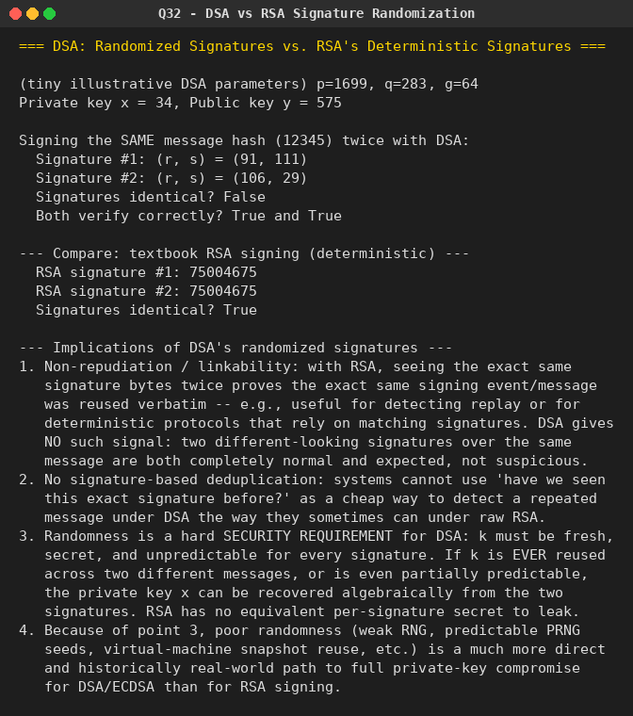

Question 33: Full DES Implementation (64-bit Block, 56-bit Key)
Problem: DES is a block cipher that encrypts data in blocks of 64 bits, producing 64 bits of ciphertext from 64 bits of plaintext. The same algorithm and key are used for encryption and decryption (with minor differences), and the key length is 56 bits. Implement DES in full.
Python Program:
# Q33. Full DES (Data Encryption Standard) implementation.
# 64-bit plaintext block in -> 64-bit ciphertext block out, 56-bit effective
# key (64 bits supplied, 8 are parity bits dropped by PC-1), 16 Feistel
# rounds, same algorithm/key used for encryption and decryption (subkeys
# just applied in reverse order for decryption -- see Q17).
#
# Verified against the official worked example from FIPS PUB 46 / NIST:
# key = 133457799BBCDFF1
# plaintext = 0123456789ABCDEF
# ciphertext= 85E813540F0AB405

IP = [58, 50, 42, 34, 26, 18, 10, 2, 60, 52, 44, 36, 28, 20, 12, 4,
62, 54, 46, 38, 30, 22, 14, 6, 64, 56, 48, 40, 32, 24, 16, 8,
57, 49, 41, 33, 25, 17, 9, 1, 59, 51, 43, 35, 27, 19, 11, 3,
61, 53, 45, 37, 29, 21, 13, 5, 63, 55, 47, 39, 31, 23, 15, 7]

FP = [40, 8, 48, 16, 56, 24, 64, 32, 39, 7, 47, 15, 55, 23, 63, 31,
38, 6, 46, 14, 54, 22, 62, 30, 37, 5, 45, 13, 53, 21, 61, 29,
36, 4, 44, 12, 52, 20, 60, 28, 35, 3, 43, 11, 51, 19, 59, 27,
34, 2, 42, 10, 50, 18, 58, 26, 33, 1, 41, 9, 49, 17, 57, 25]

E = [32, 1, 2, 3, 4, 5, 4, 5, 6, 7, 8, 9, 8, 9, 10, 11, 12, 13,
12, 13, 14, 15, 16, 17, 16, 17, 18, 19, 20, 21, 20, 21, 22, 23, 24, 25,
24, 25, 26, 27, 28, 29, 28, 29, 30, 31, 32, 1]

P = [16, 7, 20, 21, 29, 12, 28, 17, 1, 15, 23, 26, 5, 18, 31, 10,
2, 8, 24, 14, 32, 27, 3, 9, 19, 13, 30, 6, 22, 11, 4, 25]

PC1 = [57, 49, 41, 33, 25, 17, 9, 1, 58, 50, 42, 34, 26, 18,
10, 2, 59, 51, 43, 35, 27, 19, 11, 3, 60, 52, 44, 36,
63, 55, 47, 39, 31, 23, 15, 7, 62, 54, 46, 38, 30, 22,
14, 6, 61, 53, 45, 37, 29, 21, 13, 5, 28, 20, 12, 4]

PC2 = [14, 17, 11, 24, 1, 5, 3, 28, 15, 6, 21, 10,
23, 19, 12, 4, 26, 8, 16, 7, 27, 20, 13, 2,
41, 52, 31, 37, 47, 55, 30, 40, 51, 45, 33, 48,
44, 49, 39, 56, 34, 53, 46, 42, 50, 36, 29, 32]

SHIFTS = [1, 1, 2, 2, 2, 2, 2, 2, 1, 2, 2, 2, 2, 2, 2, 1]

SBOX = [
# S1
[[14, 4, 13, 1, 2, 15, 11, 8, 3, 10, 6, 12, 5, 9, 0, 7],
[0, 15, 7, 4, 14, 2, 13, 1, 10, 6, 12, 11, 9, 5, 3, 8],
[4, 1, 14, 8, 13, 6, 2, 11, 15, 12, 9, 7, 3, 10, 5, 0],
[15, 12, 8, 2, 4, 9, 1, 7, 5, 11, 3, 14, 10, 0, 6, 13]],
# S2
[[15, 1, 8, 14, 6, 11, 3, 4, 9, 7, 2, 13, 12, 0, 5, 10],
[3, 13, 4, 7, 15, 2, 8, 14, 12, 0, 1, 10, 6, 9, 11, 5],
[0, 14, 7, 11, 10, 4, 13, 1, 5, 8, 12, 6, 9, 3, 2, 15],
[13, 8, 10, 1, 3, 15, 4, 2, 11, 6, 7, 12, 0, 5, 14, 9]],
# S3
[[10, 0, 9, 14, 6, 3, 15, 5, 1, 13, 12, 7, 11, 4, 2, 8],
[13, 7, 0, 9, 3, 4, 6, 10, 2, 8, 5, 14, 12, 11, 15, 1],
[13, 6, 4, 9, 8, 15, 3, 0, 11, 1, 2, 12, 5, 10, 14, 7],
[1, 10, 13, 0, 6, 9, 8, 7, 4, 15, 14, 3, 11, 5, 2, 12]],
# S4
[[7, 13, 14, 3, 0, 6, 9, 10, 1, 2, 8, 5, 11, 12, 4, 15],
[13, 8, 11, 5, 6, 15, 0, 3, 4, 7, 2, 12, 1, 10, 14, 9],
[10, 6, 9, 0, 12, 11, 7, 13, 15, 1, 3, 14, 5, 2, 8, 4],
[3, 15, 0, 6, 10, 1, 13, 8, 9, 4, 5, 11, 12, 7, 2, 14]],
# S5
[[2, 12, 4, 1, 7, 10, 11, 6, 8, 5, 3, 15, 13, 0, 14, 9],
[14, 11, 2, 12, 4, 7, 13, 1, 5, 0, 15, 10, 3, 9, 8, 6],
[4, 2, 1, 11, 10, 13, 7, 8, 15, 9, 12, 5, 6, 3, 0, 14],
[11, 8, 12, 7, 1, 14, 2, 13, 6, 15, 0, 9, 10, 4, 5, 3]],
# S6
[[12, 1, 10, 15, 9, 2, 6, 8, 0, 13, 3, 4, 14, 7, 5, 11],
[10, 15, 4, 2, 7, 12, 9, 5, 6, 1, 13, 14, 0, 11, 3, 8],
[9, 14, 15, 5, 2, 8, 12, 3, 7, 0, 4, 10, 1, 13, 11, 6],
[4, 3, 2, 12, 9, 5, 15, 10, 11, 14, 1, 7, 6, 0, 8, 13]],
# S7
[[4, 11, 2, 14, 15, 0, 8, 13, 3, 12, 9, 7, 5, 10, 6, 1],
[13, 0, 11, 7, 4, 9, 1, 10, 14, 3, 5, 12, 2, 15, 8, 6],
[1, 4, 11, 13, 12, 3, 7, 14, 10, 15, 6, 8, 0, 5, 9, 2],
[6, 11, 13, 8, 1, 4, 10, 7, 9, 5, 0, 15, 14, 2, 3, 12]],
# S8
[[13, 2, 8, 4, 6, 15, 11, 1, 10, 9, 3, 14, 5, 0, 12, 7],
[1, 15, 13, 8, 10, 3, 7, 4, 12, 5, 6, 11, 0, 14, 9, 2],
[7, 11, 4, 1, 9, 12, 14, 2, 0, 6, 10, 13, 15, 3, 5, 8],
[2, 1, 14, 7, 4, 10, 8, 13, 15, 12, 9, 0, 3, 5, 6, 11]],
]

def permute(bits, table):
return [bits[i - 1] for i in table]

def left_rotate(bits, n):
return bits[n:] + bits[:n]

def xor(a, b):
return [x ^ y for x, y in zip(a, b)]

def bytes_to_bits(data8):
bits = []
for byte in data8:
bits.extend(int(b) for b in f"{byte:08b}")
return bits

def bits_to_hex(bits):
val = 0
for b in bits:
val = (val << 1) | b
return f"{val:0{len(bits)//4}X}"

def generate_round_keys(key64bits):
key56 = permute(key64bits, PC1)
C, D = key56[:28], key56[28:]
round_keys = []
for shift in SHIFTS:
C = left_rotate(C, shift)
D = left_rotate(D, shift)
round_keys.append(permute(C + D, PC2))
return round_keys

def sbox_substitute(bits48):
output = []
for i in range(8):
block6 = bits48[i * 6:i * 6 + 6]
row = (block6[0] << 1) | block6[5]
col = (block6[1] << 3) | (block6[2] << 2) | (block6[3] << 1) | block6[4]
val = SBOX[i][row][col]
output.extend(int(b) for b in f"{val:04b}")
return output

def feistel(R, subkey):
expanded = permute(R, E)
xored = xor(expanded, subkey)
sboxed = sbox_substitute(xored)
return permute(sboxed, P)

def des_process(block64bits, round_keys):
"""round_keys given in the order they should be USED (K1..K16 for
encryption; K16..K1 for decryption)."""
bits = permute(block64bits, IP)
L, R = bits[:32], bits[32:]
for rk in round_keys:
new_L = R
new_R = xor(L, feistel(R, rk))
L, R = new_L, new_R
pre_output = R + L # note the final swap
return permute(pre_output, FP)

def des_encrypt_block(plaintext64bits, key64bits):
round_keys = generate_round_keys(key64bits)
return des_process(plaintext64bits, round_keys)

def des_decrypt_block(ciphertext64bits, key64bits):
round_keys = generate_round_keys(key64bits)
return des_process(ciphertext64bits, list(reversed(round_keys)))

def hex_to_bits(hex_str):
data = bytes.fromhex(hex_str)
return bytes_to_bits(data)

if __name__ == "__main__":
print("=== Full DES Implementation (64-bit block, 56-bit effective key) ===\n")

# Official FIPS PUB 46 worked example
key_hex = "133457799BBCDFF1"
plain_hex = "0123456789ABCDEF"
expected_cipher_hex = "85E813540F0AB405"

key_bits = hex_to_bits(key_hex)
plain_bits = hex_to_bits(plain_hex)

cipher_bits = des_encrypt_block(plain_bits, key_bits)
cipher_hex = bits_to_hex(cipher_bits)

print(f"Key : {key_hex}")
print(f"Plaintext : {plain_hex}")
print(f"Ciphertext: {cipher_hex}")
print(f"Expected : {expected_cipher_hex} (official FIPS PUB 46 test vector)")
print(f"Matches official test vector: {cipher_hex == expected_cipher_hex}\n")

decrypted_bits = des_decrypt_block(cipher_bits, key_bits)
decrypted_hex = bits_to_hex(decrypted_bits)
print(f"Decrypted : {decrypted_hex}")
print(f"Round-trip correct: {decrypted_hex == plain_hex}\n")

print("--- Additional demonstration: encrypting a text message (as hex blocks) ---")
message = "SECURE!!" # exactly 8 bytes = one 64-bit block
msg_hex = message.encode().hex()
msg_bits = hex_to_bits(msg_hex)
demo_key_bits = hex_to_bits("0E329232EA6D0D73")

demo_cipher_bits = des_encrypt_block(msg_bits, demo_key_bits)
demo_decrypted_bits = des_decrypt_block(demo_cipher_bits, demo_key_bits)
recovered_text = bytes(int(''.join(map(str, demo_decrypted_bits[i:i+8])), 2)
for i in range(0, 64, 8)).decode()

print(f"Message : {message!r}")
print(f"Ciphertext : {bits_to_hex(demo_cipher_bits)}")
print(f"Recovered : {recovered_text!r} (matches: {recovered_text == message})")

Output:
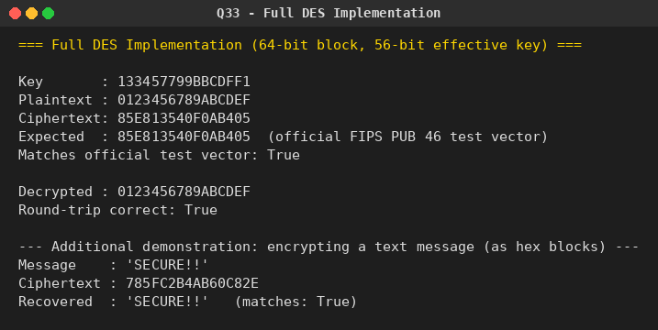

Question 34: ECB, CBC, and CFB Modes with Mandatory Bit-Padding
Problem: (Identical to Question 21.) For ECB, CBC, and CFB modes, the plaintext must be a positive multiple of the block (or segment) size. Pad using a 1 bit followed by as few zero bits as necessary, and always pad every message, even when the final block is already complete. What is the motivation for including a padding block when padding is not needed?
This is the same question as Question 21; the identical program and output are reused here.
Python Program:
# Q21. ECB, CBC, and CFB modes require the plaintext to be a positive multiple
# of the block/segment size. We implement the standard "bit padding" scheme:
# append a single 1 bit, then as few 0 bits as necessary (possibly none) to
# fill out the final block -- and we ALWAYS pad, even when the plaintext is
# already an exact multiple of the block size.
#
# We use a simple, illustrative 8-bit toy block cipher (byte-wise substitution
# + fixed permutation) so the padding/mode-of-operation logic is easy to see;
# the modes themselves work identically with any real block cipher (DES,
# AES, S-DES, etc. -- see Q22/Q23 for a real S-DES-based CBC/CTR demo).

import os

BLOCK_SIZE = 8 # bits (1 byte), for compact demonstration

# --- a tiny toy block "cipher" (NOT cryptographically secure -- illustrative only) ---
SBOX = list(range(256))
import random
random.seed(99)
random.shuffle(SBOX)
INV_SBOX = [0] * 256
for i, v in enumerate(SBOX):
INV_SBOX[v] = i

def toy_encrypt_byte(byte_val, key_byte):
return SBOX[(byte_val ^ key_byte) & 0xFF]

def toy_decrypt_byte(byte_val, key_byte):
return INV_SBOX[byte_val] ^ key_byte

# --- bit-padding (append 1 then 0s) ---
def pad_bits(data: bytes, block_bytes=1):
bits = ''.join(f'{b:08b}' for b in data)
bits += '1'
while len(bits) % (block_bytes * 8) != 0:
bits += '0'
padded = bytes(int(bits[i:i + 8], 2) for i in range(0, len(bits), 8))
return padded

def unpad_bits(data: bytes):
bits = ''.join(f'{b:08b}' for b in data)
idx = bits.rfind('1')
if idx == -1:
raise ValueError("No padding bit found -- corrupted data")
data_bits = bits[:idx]
out_bytes = bytearray()
for i in range(0, len(data_bits), 8):
out_bytes.append(int(data_bits[i:i + 8], 2))
return bytes(out_bytes)

# --- ECB ---
def ecb_encrypt(data: bytes, key: int):
padded = pad_bits(data)
return bytes(toy_encrypt_byte(b, key) for b in padded)

def ecb_decrypt(cipher: bytes, key: int):
plain_padded = bytes(toy_decrypt_byte(b, key) for b in cipher)
return unpad_bits(plain_padded)

# --- CBC ---
def cbc_encrypt(data: bytes, key: int, iv: int):
padded = pad_bits(data)
prev = iv
out = bytearray()
for b in padded:
c = toy_encrypt_byte(b ^ prev, key)
out.append(c)
prev = c
return bytes(out)

def cbc_decrypt(cipher: bytes, key: int, iv: int):
prev = iv
out = bytearray()
for c in cipher:
p = toy_decrypt_byte(c, key) ^ prev
out.append(p)
prev = c
return unpad_bits(bytes(out))

# --- CFB (full-byte feedback, byte-oriented for this toy cipher) ---
def cfb_encrypt(data: bytes, key: int, iv: int):
padded = pad_bits(data)
shift_reg = iv
out = bytearray()
for b in padded:
keystream = toy_encrypt_byte(shift_reg, key) # encrypt the shift register
c = b ^ keystream
out.append(c)
shift_reg = c
return bytes(out)

def cfb_decrypt(cipher: bytes, key: int, iv: int):
shift_reg = iv
out = bytearray()
for c in cipher:
keystream = toy_encrypt_byte(shift_reg, key)
p = c ^ keystream
out.append(p)
shift_reg = c
return unpad_bits(bytes(out))

if __name__ == "__main__":
key = 0x5A
iv = 0x3C

print("=== ECB / CBC / CFB with Mandatory Bit-Padding ===\n")

for label, message in [
("Message NOT a multiple of block size", b"HELLO"),
("Message that IS already a whole number of blocks", b"ABCDEFGH"),
]:
print(f"--- {label} ---")
print(f"Plaintext: {message} ({len(message)} bytes)")
padded = pad_bits(message)
print(f"Padded : {padded.hex()} ({len(padded)} bytes) "
f"[always padded, even when {len(message)} was already a multiple of {BLOCK_SIZE//8}]")

ecb_c = ecb_encrypt(message, key)
ecb_p = ecb_decrypt(ecb_c, key)
print(f"ECB ciphertext: {ecb_c.hex()} decrypted: {ecb_p}")

cbc_c = cbc_encrypt(message, key, iv)
cbc_p = cbc_decrypt(cbc_c, key, iv)
print(f"CBC ciphertext: {cbc_c.hex()} decrypted: {cbc_p}")

cfb_c = cfb_encrypt(message, key, iv)
cfb_p = cfb_decrypt(cfb_c, key, iv)
print(f"CFB ciphertext: {cfb_c.hex()} decrypted: {cfb_p}\n")

print("--- Why pad even when padding isn't strictly needed? ---")
print("If padding is applied only conditionally (skipped whenever the plaintext")
print("already fills whole blocks), the receiver can no longer unambiguously")
print("tell whether the final block's trailing bits are genuine message content")
print("or a padding marker. A legitimate final block that happens to end in a")
print("'1' bit followed by zeros is then indistinguishable from 'no real data")
print("here, this is padding' and would be wrongly stripped -- silently")
print("corrupting the message. Always appending a padding block (even a full")
print("extra dummy block, or here, always appending at least the 1-bit marker)")
print("removes this ambiguity: the receiver's unpadding rule is unconditional")
print("and unambiguous for every message, with no special case to get wrong.")

Output:


Question 35: One-Time Pad Version of the Vigenère Cipher
Problem: (Identical to Question 14.) The key is a stream of random numbers between 0 and 26. If the key is 3 19 5 ..., the first letter of plaintext is encrypted with a shift of 3 letters, the second with a shift of 19, the third with a shift of 5, and so on.
This is the same question as Question 14; the identical program and output are reused here.
Python Program:
# Q14. One-time-pad version of the Vigenere cipher.
# Key is a stream of random numbers (shifts) between 0 and 26.
# a. Encrypt "send more money" with key stream 9 0 1 7 23 15 21 14 11 11 2 8 9
# b. Given the ciphertext from (a), find a DIFFERENT key stream that decrypts
# it to "cash not needed" -- demonstrating a one-time pad gives perfect
# secrecy (any plaintext of the same length is equally possible).

def otp_encrypt(text, key_stream):
text = text.replace(" ", "").upper()
result = []
for ch, k in zip(text, key_stream):
p = ord(ch) - 65
c = (p + k) % 26
result.append(chr(c + 65))
return ''.join(result)

def otp_decrypt(cipher, key_stream):
result = []
for ch, k in zip(cipher, key_stream):
c = ord(ch) - 65
p = (c - k) % 26
result.append(chr(p + 65))
return ''.join(result)

def find_key_for_target(cipher, target):
target = target.replace(" ", "").upper()
key = []
for c_ch, t_ch in zip(cipher, target):
c = ord(c_ch) - 65
p = ord(t_ch) - 65
k = (c - p) % 26
key.append(k)
return key

if __name__ == "__main__":
print("=== One-Time Pad (Vigenere) Cipher ===")

plaintext_a = "send more money"
key_a = [9, 0, 1, 7, 23, 15, 21, 14, 11, 11, 2, 8, 9]

ciphertext = otp_encrypt(plaintext_a, key_a)
print(f"a. Plaintext : {plaintext_a}")
print(f" Key stream: {key_a}")
print(f" Ciphertext: {ciphertext}")
print(f" Verify decrypt -> {otp_decrypt(ciphertext, key_a)}")

target_plain = "cash not needed"
key_b = find_key_for_target(ciphertext, target_plain)
print(f"\nb. Same ciphertext: {ciphertext}")
print(f" Target plaintext : {target_plain}")
print(f" Required key stream: {key_b}")
print(f" Verify decrypt -> {otp_decrypt(ciphertext, key_b)}")

print("\nThis shows that for a true one-time pad, the same ciphertext can be")
print("decrypted to ANY plaintext of equal length with the right key --")
print("hence brute force / cryptanalysis is impossible without the key.")

Output:


Question 36: The Affine Caesar Cipher and the One-to-One Requirement
Problem: (Identical to Question 5.) For each plaintext letter p, substitute the ciphertext letter C = E([a, b], p) = (ap + b) mod 26. An encryption algorithm must be one-to-one, but the affine Caesar cipher is not one-to-one for all values of a -- e.g. for a = 2, b = 3, E([a,b], 0) = E([a,b], 13) = 3.
This is the same question as Question 5; the identical program and output are reused here.
Python Program:
# Q5. Affine Caesar Cipher
# C = E([a, b], p) = (a*p + b) mod 26
# For the cipher to be one-to-one (invertible), gcd(a, 26) must equal 1.

from math import gcd

def affine_encrypt(text, a, b):
result = []
for ch in text:
if ch.isalpha():
base = 65 if ch.isupper() else 97
p = ord(ch) - base
c = (a * p + b) % 26
result.append(chr(c + base))
else:
result.append(ch)
return ''.join(result)

def mod_inverse(a, m=26):
for x in range(1, m):
if (a * x) % m == 1:
return x
return None

def affine_decrypt(text, a, b):
a_inv = mod_inverse(a)
result = []
for ch in text:
if ch.isalpha():
base = 65 if ch.isupper() else 97
c = ord(ch) - base
p = (a_inv * (c - b)) % 26
result.append(chr(p + base))
else:
result.append(ch)
return ''.join(result)

if __name__ == "__main__":
print("=== Affine Caesar Cipher ===")

a, b = 5, 3 # example valid values
plaintext = "AFFINE CIPHER"
ciphertext = affine_encrypt(plaintext, a, b)
decrypted = affine_decrypt(ciphertext, a, b)

print(f"a = {a}, b = {b}")
print(f"Plaintext : {plaintext}")
print(f"Ciphertext: {ciphertext}")
print(f"Decrypted : {decrypted}")

print("\n--- Analysis questions ---")
print("a. Are there any limitations on the value of b?")
print(" No. b may be any value 0-25; every b gives a valid shift component,")
print(" so b alone never breaks the one-to-one property.")

print("\nb. Which values of a are NOT allowed?")
not_allowed = [x for x in range(1, 26) if gcd(x, 26) != 1]
allowed = [x for x in range(1, 26) if gcd(x, 26) == 1]
print(f" a must satisfy gcd(a, 26) = 1 (so that a has an inverse mod 26).")
print(f" Allowed values of a : {allowed}")
print(f" NOT allowed values of a : {not_allowed}")

Output:


Question 37: Automated Frequency Attack on a Monoalphabetic Substitution Cipher
Problem: (Identical to Question 16.) Perform a letter frequency attack on any monoalphabetic substitution cipher without human intervention, producing possible plaintexts in rough order of likelihood, with a 'give me the top 10 possible plaintexts' option.
This is the same question as Question 16; the identical program and output are reused here.
Python Program:
# Q16. Letter-frequency attack on a general MONOALPHABETIC SUBSTITUTION cipher,
# without human intervention.
#
# A monoalphabetic substitution has 26! possible keys, so brute force is
# impossible. Instead we use:
# 1. Frequency matching -> a good starting guess (map ciphertext letters to
# plaintext letters by matching frequency rank order).
# 2. Simulated annealing -> repeatedly try swapping two letters in the
# candidate key; accept improving swaps always, and occasionally accept
# worsening swaps (with probability that shrinks over time) to escape
# local optima. Fitness = log-probability of the decrypted text under an
# English bigram+trigram model.
# 3. Multiple random restarts, keeping the best distinct plaintexts found,
# to report the "top N most likely plaintexts."

import math
import random
import string
from collections import Counter

# Approximate relative frequencies of common English bigrams/trigrams
# (hand-curated, small tables -- enough signal to guide the search for a lab demo).
ENGLISH_BIGRAMS = {
"th": 27, "he": 23, "in": 17, "er": 17, "an": 16, "re": 14, "on": 13,
"at": 12, "en": 12, "nd": 11, "ti": 11, "es": 11, "or": 10, "te": 10,
"of": 10, "ed": 9, "is": 9, "it": 9, "al": 9, "ar": 9, "st": 9, "to": 9,
"nt": 8, "ng": 8, "se": 8, "ha": 8, "as": 8, "ou": 8, "io": 7, "le": 7,
"ve": 7, "co": 6, "me": 6, "de": 6, "hi": 6, "ri": 6, "ro": 6, "ic": 6,
"ne": 6, "ea": 6, "ra": 6, "ce": 5, "li": 5, "ch": 5, "ll": 5, "be": 5,
"ma": 5, "si": 5, "om": 5, "ur": 5, "wi": 4, "ss": 4, "ho": 4, "wa": 4,
"ns": 4, "ot": 4, "no": 4, "fo": 4, "ta": 4, "ee": 4, "sa": 4,
}
ENGLISH_TRIGRAMS = {
"the": 34, "and": 15, "ing": 15, "ion": 11, "ent": 9, "her": 8, "for": 7,
"tha": 7, "nth": 6, "int": 6, "ere": 6, "tio": 6, "ter": 6, "est": 6,
"ers": 6, "ati": 6, "hat": 5, "ate": 5, "all": 5, "eth": 5, "hes": 5,
"ver": 5, "his": 5, "oft": 4, "ith": 4, "fth": 4, "sth": 4, "oth": 4,
"res": 4, "ont": 4, "com": 4, "men": 4,
}

LOG_TOTAL_BI = math.log(sum(ENGLISH_BIGRAMS.values()) * 4)
LOG_TOTAL_TRI = math.log(sum(ENGLISH_TRIGRAMS.values()) * 4)
# Unseen n-grams are assumed rarer than anything in our table (assumed
# frequency 0.5, well below the smallest listed value of 4) so that matching
# a *known* common bigram/trigram always scores strictly better than missing.
FLOOR_BI = math.log(0.5) - LOG_TOTAL_BI
FLOOR_TRI = math.log(0.5) - LOG_TOTAL_TRI

def score_text(text):
text = ''.join(ch for ch in text.lower() if ch.isalpha())
score = 0.0
for i in range(len(text) - 1):
bg = text[i:i + 2]
f = ENGLISH_BIGRAMS.get(bg)
score += (math.log(f) - LOG_TOTAL_BI) if f else FLOOR_BI
for i in range(len(text) - 2):
tg = text[i:i + 3]
f = ENGLISH_TRIGRAMS.get(tg)
score += 1.5 * ((math.log(f) - LOG_TOTAL_TRI) if f else FLOOR_TRI)
return score

def decrypt_with_key(ciphertext, key):
result = []
for ch in ciphertext:
if ch.isalpha():
dec = key.get(ch.lower(), ch.lower())
result.append(dec.upper() if ch.isupper() else dec)
else:
result.append(ch)
return ''.join(result)

def frequency_initial_key(ciphertext):
english_order = "etaoinshrdlcumwfgypbvkjxqz"
counts = Counter(ch.lower() for ch in ciphertext if ch.isalpha())
cipher_order = [c for c, _ in counts.most_common()]
for c in string.ascii_lowercase:
if c not in cipher_order:
cipher_order.append(c)
key = {}
for i, c in enumerate(cipher_order):
key[c] = english_order[i] if i < len(english_order) else c
return key

def simulated_annealing(ciphertext, start_key, iterations, rng):
key = dict(start_key)
score = score_text(decrypt_with_key(ciphertext, key))
best_key, best_score = dict(key), score
letters = list(string.ascii_lowercase)

T0, Tmin = 3.0, 0.05
for step in range(iterations):
T = max(Tmin, T0 * (1 - step / iterations))
a, b = rng.sample(letters, 2)
new_key = dict(key)
va, vb = new_key.get(a, a), new_key.get(b, b)
new_key[a], new_key[b] = vb, va
new_score = score_text(decrypt_with_key(ciphertext, new_key))

if new_score > score or rng.random() < math.exp((new_score - score) / T):
key, score = new_key, new_score
if score > best_score:
best_key, best_score = dict(key), score
return best_key, best_score

def attack(ciphertext, restarts=10, iterations=6000, top_n=10, seed=1):
rng = random.Random(seed)
base_key = frequency_initial_key(ciphertext)
candidates = {}
for r in range(restarts):
key = dict(base_key)
letters = list(string.ascii_lowercase)
shuffle_amount = 0 if r == 0 else rng.randint(1, 4)
for _ in range(shuffle_amount):
a, b = rng.sample(letters, 2)
key[a], key[b] = key.get(b, b), key.get(a, a)
final_key, score = simulated_annealing(ciphertext, key, iterations, rng)
plain = decrypt_with_key(ciphertext, final_key)
candidates[plain] = max(candidates.get(plain, float("-inf")), score)

ranked = sorted(candidates.items(), key=lambda kv: kv[1], reverse=True)
return ranked[:top_n]

if __name__ == "__main__":
print("=== Automated Frequency Attack on a Monoalphabetic Substitution Cipher ===")

random.seed(7)
plain_alpha = list(string.ascii_lowercase)
cipher_alpha = plain_alpha.copy()
random.shuffle(cipher_alpha)
enc_map = dict(zip(plain_alpha, cipher_alpha))

secret_plaintext = (
"this cryptographic attack recovers the original plaintext without "
"any human intervention by combining letter frequency analysis with "
"a simulated annealing search over the entire key space so that the "
"correct substitution alphabet is discovered automatically from the "
"statistical structure of the english language and the program can "
"then report the most likely plaintexts it has found in ranked order"
)
ciphertext = ''.join(enc_map.get(c, c) for c in secret_plaintext)

print(f"(demo) Original plaintext: {secret_plaintext}")
print(f"(demo) Ciphertext : {ciphertext}\n")

print("Give me the top 10 possible plaintexts:\n")
results = attack(ciphertext, restarts=10, iterations=6000, top_n=10, seed=42)
for rank, (plain, score) in enumerate(results, start=1):
marker = " <-- best candidate" if rank == 1 else ""
print(f"{rank:2d}. score={score:9.1f} {plain}{marker}")

Output:


Question 38: Hill Cipher: Chosen-Plaintext Attack
Problem: The Hill cipher succumbs to a known-plaintext attack if sufficient plaintext-ciphertext pairs are provided (see Question 13). It is even easier to solve the Hill cipher if a chosen-plaintext attack can be mounted. Implement this.
Python Program:
# Q38. The Hill cipher succumbs to a known-plaintext attack given enough
# plaintext-ciphertext pairs (see Q13). It is even EASIER to break with a
# CHOSEN-plaintext attack: the attacker gets to pick convenient plaintext
# digraphs rather than hoping a natural message happens to provide a
# solvable (invertible) plaintext matrix.
#
# The cleanest choice: choose plaintext blocks equal to the standard basis
# vectors, e.g. for a 2x2 key, choose P1 = "BA" (=[1,0]) and P2 = "AC"
# (=[0,2])... more simply, choose the plaintext MATRIX to be the identity
# matrix I. Then C = K*P = K*I = K -- the ciphertext IS the key, read off
# directly with no linear algebra at all!

import numpy as np

def mod_inverse(a, m=26):
a = a % m
for x in range(1, m):
if (a * x) % m == 1:
return x
return None

def matrix_mod_inverse(matrix, modulus=26):
det = int(round(np.linalg.det(matrix)))
det_inv = mod_inverse(det % modulus, modulus)
if det_inv is None:
return None
adj = np.array([[matrix[1][1], -matrix[0][1]],
[-matrix[1][0], matrix[0][0]]])
return (det_inv * adj) % modulus

def text_to_vecs(text):
nums = [ord(c) - 65 for c in text.upper()]
return np.array(nums).reshape(-1, 2).T

def vecs_to_text(vecs):
flat = vecs.T.flatten()
return ''.join(chr(int(v) % 26 + 65) for v in flat)

def hill_encrypt_vecs(P, key):
return np.dot(key, P) % 26

if __name__ == "__main__":
print("=== Hill Cipher: Chosen-Plaintext Attack (Even Easier Than Known-Plaintext) ===\n")

# The real key, unknown to the attacker -- but the attacker gets an
# encryption oracle: they may submit ANY plaintext and observe its ciphertext.
true_key = np.array([[9, 4], [5, 7]])
print("(unknown to attacker) True key matrix:")
print(true_key, "\n")

print("--- Known-plaintext attack (recap from Q13): needs an invertible P ---")
print("The attacker must WAIT for or already possess plaintext-ciphertext pairs")
print("whose plaintext matrix P happens to be invertible mod 26 -- not")
print("guaranteed for arbitrary intercepted text.\n")

print("--- Chosen-plaintext attack: attacker actively PICKS the plaintext ---")
print("Choose the plaintext matrix P = the 2x2 IDENTITY matrix -- i.e. submit")
print("the two plaintext digraphs whose numeric column vectors are [1,0] and")
print("[0,1] (letters 'B A' and 'A B'):")

chosen_plain_text = "BAAB" # digraph1 = "BA" = [1,0]; digraph2 = "AB" = [0,1]
P = text_to_vecs(chosen_plain_text)
print(f" Chosen plaintext: {chosen_plain_text} -> P =\n{P}\n")

# The attacker submits P to the encryption oracle (i.e. gets it encrypted
# under the real, unknown key) and observes C.
C = hill_encrypt_vecs(P, true_key)
chosen_cipher_text = vecs_to_text(C)
print(f"Oracle returns ciphertext: {chosen_cipher_text} -> C =\n{C}\n")

print("Since P = I (the identity matrix), C = K*P = K*I = K directly --")
print("the ciphertext matrix IS the key matrix. No matrix inversion, no")
print("linear algebra at all is needed:")
recovered_key_trivial = C
print(recovered_key_trivial)
print(f"Recovered key matches the true key: {np.array_equal(recovered_key_trivial, true_key)}\n")

print("--- For comparison: the general (known-plaintext) formula still works too ---")
P_inv = matrix_mod_inverse(P)
recovered_key_general = np.dot(C, P_inv) % 26
print(f"K = C * P^-1 (mod 26) =\n{recovered_key_general}")
print(f"Matches true key: {np.array_equal(recovered_key_general, true_key)}\n")

print("--- Conclusion ---")
print("A chosen-plaintext attacker doesn't need to search for or wait for a")
print("conveniently invertible plaintext matrix, and doesn't need to perform")
print("any modular matrix inversion at all -- choosing P = I makes the")
print("ciphertext equal to the key by construction. This is why chosen-")
print("plaintext attacks are strictly more powerful than known-plaintext")
print("attacks against the (linear, and therefore fundamentally weak) Hill cipher.")

Output:
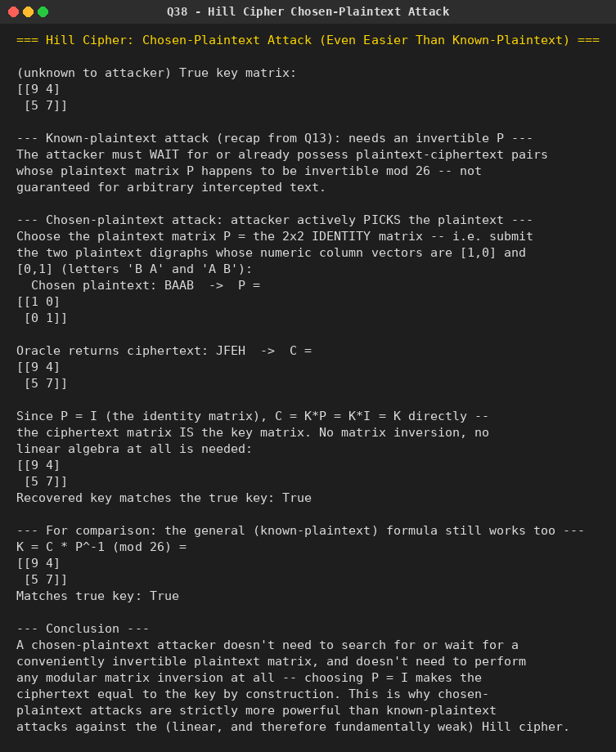

Question 39: Automated Frequency Attack on an Additive Cipher
Problem: (Identical to Question 15.) Perform a letter frequency attack on an additive cipher without human intervention, producing possible plaintexts in rough order of likelihood, with a 'give me the top 10 possible plaintexts' option.
This is the same question as Question 15; the identical program and output are reused here.
Python Program:
# Q15. Automated letter-frequency attack on an additive (Caesar) cipher.
# Tries all 26 shifts, scores each candidate plaintext against standard
# English letter frequencies using a chi-squared statistic, and returns
# the top-N most likely plaintexts (lower chi-squared = more English-like).

ENGLISH_FREQ = {
'a': 8.2, 'b': 1.5, 'c': 2.8, 'd': 4.3, 'e': 12.7, 'f': 2.2, 'g': 2.0,
'h': 6.1, 'i': 7.0, 'j': 0.15, 'k': 0.77, 'l': 4.0, 'm': 2.4, 'n': 6.7,
'o': 7.5, 'p': 1.9, 'q': 0.095, 'r': 6.0, 's': 6.3, 't': 9.1, 'u': 2.8,
'v': 0.98, 'w': 2.4, 'x': 0.15, 'y': 2.0, 'z': 0.074
}

def shift_text(text, k):
result = []
for ch in text:
if ch.isalpha():
base = 65 if ch.isupper() else 97
result.append(chr((ord(ch) - base + k) % 26 + base))
else:
result.append(ch)
return ''.join(result)

def chi_squared_score(text):
text = text.lower()
n = sum(1 for ch in text if ch.isalpha())
if n == 0:
return float('inf')
counts = {c: 0 for c in ENGLISH_FREQ}
for ch in text:
if ch in counts:
counts[ch] += 1
score = 0.0
for c, expected_pct in ENGLISH_FREQ.items():
observed = counts[c]
expected = expected_pct / 100 * n
score += (observed - expected) ** 2 / expected
return score

def top_n_candidates(ciphertext, n=10):
candidates = []
for k in range(26):
plain = shift_text(ciphertext, k)
score = chi_squared_score(plain)
candidates.append((score, k, plain))
candidates.sort(key=lambda x: x[0])
return candidates[:n]

if __name__ == "__main__":
print("=== Automated Frequency Attack on an Additive Cipher ===")

original_shift = 11
plaintext = "meet me after the toga party"
ciphertext = shift_text(plaintext, original_shift)

print(f"(demo) Original plaintext : {plaintext}")
print(f"(demo) Encrypted with k={original_shift}: {ciphertext}\n")

print("Give me the top 10 possible plaintexts:\n")
results = top_n_candidates(ciphertext, n=10)
for rank, (score, k, plain) in enumerate(results, start=1):
marker = " <-- most likely" if rank == 1 else ""
print(f"{rank:2d}. shift={k:2d} chi^2={score:7.2f} {plain}{marker}")

Output:


Question 40: Automated Frequency Attack on a Monoalphabetic Substitution Cipher
Problem: (Identical to Questions 16 and 37.) Perform a letter frequency attack on any monoalphabetic substitution cipher without human intervention, producing possible plaintexts in rough order of likelihood, with a 'give me the top 10 possible plaintexts' option.
This is the same question as Questions 16 and 37; the identical program and output are reused here.
Python Program:
# Q16. Letter-frequency attack on a general MONOALPHABETIC SUBSTITUTION cipher,
# without human intervention.
#
# A monoalphabetic substitution has 26! possible keys, so brute force is
# impossible. Instead we use:
# 1. Frequency matching -> a good starting guess (map ciphertext letters to
# plaintext letters by matching frequency rank order).
# 2. Simulated annealing -> repeatedly try swapping two letters in the
# candidate key; accept improving swaps always, and occasionally accept
# worsening swaps (with probability that shrinks over time) to escape
# local optima. Fitness = log-probability of the decrypted text under an
# English bigram+trigram model.
# 3. Multiple random restarts, keeping the best distinct plaintexts found,
# to report the "top N most likely plaintexts."

import math
import random
import string
from collections import Counter

# Approximate relative frequencies of common English bigrams/trigrams
# (hand-curated, small tables -- enough signal to guide the search for a lab demo).
ENGLISH_BIGRAMS = {
"th": 27, "he": 23, "in": 17, "er": 17, "an": 16, "re": 14, "on": 13,
"at": 12, "en": 12, "nd": 11, "ti": 11, "es": 11, "or": 10, "te": 10,
"of": 10, "ed": 9, "is": 9, "it": 9, "al": 9, "ar": 9, "st": 9, "to": 9,
"nt": 8, "ng": 8, "se": 8, "ha": 8, "as": 8, "ou": 8, "io": 7, "le": 7,
"ve": 7, "co": 6, "me": 6, "de": 6, "hi": 6, "ri": 6, "ro": 6, "ic": 6,
"ne": 6, "ea": 6, "ra": 6, "ce": 5, "li": 5, "ch": 5, "ll": 5, "be": 5,
"ma": 5, "si": 5, "om": 5, "ur": 5, "wi": 4, "ss": 4, "ho": 4, "wa": 4,
"ns": 4, "ot": 4, "no": 4, "fo": 4, "ta": 4, "ee": 4, "sa": 4,
}
ENGLISH_TRIGRAMS = {
"the": 34, "and": 15, "ing": 15, "ion": 11, "ent": 9, "her": 8, "for": 7,
"tha": 7, "nth": 6, "int": 6, "ere": 6, "tio": 6, "ter": 6, "est": 6,
"ers": 6, "ati": 6, "hat": 5, "ate": 5, "all": 5, "eth": 5, "hes": 5,
"ver": 5, "his": 5, "oft": 4, "ith": 4, "fth": 4, "sth": 4, "oth": 4,
"res": 4, "ont": 4, "com": 4, "men": 4,
}

LOG_TOTAL_BI = math.log(sum(ENGLISH_BIGRAMS.values()) * 4)
LOG_TOTAL_TRI = math.log(sum(ENGLISH_TRIGRAMS.values()) * 4)
# Unseen n-grams are assumed rarer than anything in our table (assumed
# frequency 0.5, well below the smallest listed value of 4) so that matching
# a *known* common bigram/trigram always scores strictly better than missing.
FLOOR_BI = math.log(0.5) - LOG_TOTAL_BI
FLOOR_TRI = math.log(0.5) - LOG_TOTAL_TRI

def score_text(text):
text = ''.join(ch for ch in text.lower() if ch.isalpha())
score = 0.0
for i in range(len(text) - 1):
bg = text[i:i + 2]
f = ENGLISH_BIGRAMS.get(bg)
score += (math.log(f) - LOG_TOTAL_BI) if f else FLOOR_BI
for i in range(len(text) - 2):
tg = text[i:i + 3]
f = ENGLISH_TRIGRAMS.get(tg)
score += 1.5 * ((math.log(f) - LOG_TOTAL_TRI) if f else FLOOR_TRI)
return score

def decrypt_with_key(ciphertext, key):
result = []
for ch in ciphertext:
if ch.isalpha():
dec = key.get(ch.lower(), ch.lower())
result.append(dec.upper() if ch.isupper() else dec)
else:
result.append(ch)
return ''.join(result)

def frequency_initial_key(ciphertext):
english_order = "etaoinshrdlcumwfgypbvkjxqz"
counts = Counter(ch.lower() for ch in ciphertext if ch.isalpha())
cipher_order = [c for c, _ in counts.most_common()]
for c in string.ascii_lowercase:
if c not in cipher_order:
cipher_order.append(c)
key = {}
for i, c in enumerate(cipher_order):
key[c] = english_order[i] if i < len(english_order) else c
return key

def simulated_annealing(ciphertext, start_key, iterations, rng):
key = dict(start_key)
score = score_text(decrypt_with_key(ciphertext, key))
best_key, best_score = dict(key), score
letters = list(string.ascii_lowercase)

T0, Tmin = 3.0, 0.05
for step in range(iterations):
T = max(Tmin, T0 * (1 - step / iterations))
a, b = rng.sample(letters, 2)
new_key = dict(key)
va, vb = new_key.get(a, a), new_key.get(b, b)
new_key[a], new_key[b] = vb, va
new_score = score_text(decrypt_with_key(ciphertext, new_key))

if new_score > score or rng.random() < math.exp((new_score - score) / T):
key, score = new_key, new_score
if score > best_score:
best_key, best_score = dict(key), score
return best_key, best_score

def attack(ciphertext, restarts=10, iterations=6000, top_n=10, seed=1):
rng = random.Random(seed)
base_key = frequency_initial_key(ciphertext)
candidates = {}
for r in range(restarts):
key = dict(base_key)
letters = list(string.ascii_lowercase)
shuffle_amount = 0 if r == 0 else rng.randint(1, 4)
for _ in range(shuffle_amount):
a, b = rng.sample(letters, 2)
key[a], key[b] = key.get(b, b), key.get(a, a)
final_key, score = simulated_annealing(ciphertext, key, iterations, rng)
plain = decrypt_with_key(ciphertext, final_key)
candidates[plain] = max(candidates.get(plain, float("-inf")), score)

ranked = sorted(candidates.items(), key=lambda kv: kv[1], reverse=True)
return ranked[:top_n]

if __name__ == "__main__":
print("=== Automated Frequency Attack on a Monoalphabetic Substitution Cipher ===")

random.seed(7)
plain_alpha = list(string.ascii_lowercase)
cipher_alpha = plain_alpha.copy()
random.shuffle(cipher_alpha)
enc_map = dict(zip(plain_alpha, cipher_alpha))

secret_plaintext = (
"this cryptographic attack recovers the original plaintext without "
"any human intervention by combining letter frequency analysis with "
"a simulated annealing search over the entire key space so that the "
"correct substitution alphabet is discovered automatically from the "
"statistical structure of the english language and the program can "
"then report the most likely plaintexts it has found in ranked order"
)
ciphertext = ''.join(enc_map.get(c, c) for c in secret_plaintext)

print(f"(demo) Original plaintext: {secret_plaintext}")
print(f"(demo) Ciphertext : {ciphertext}\n")

print("Give me the top 10 possible plaintexts:\n")
results = attack(ciphertext, restarts=10, iterations=6000, top_n=10, seed=42)
for rank, (plain, score) in enumerate(results, start=1):
marker = " <-- best candidate" if rank == 1 else ""
print(f"{rank:2d}. score={score:9.1f} {plain}{marker}")

Output:


